ASSIGNMENT-3  
Creation of Block Storage (EBS) with in the same region  
a) change the instance type from t2.micro ---t2.medium  
b) creation the volumes  
 i)Attach the volume   
 ii) Mount the volume and persist volumes  
 iii) Detach the Volume  
Note:- after detaching volume attach the to other instance and check whether reelected in this virtual machine

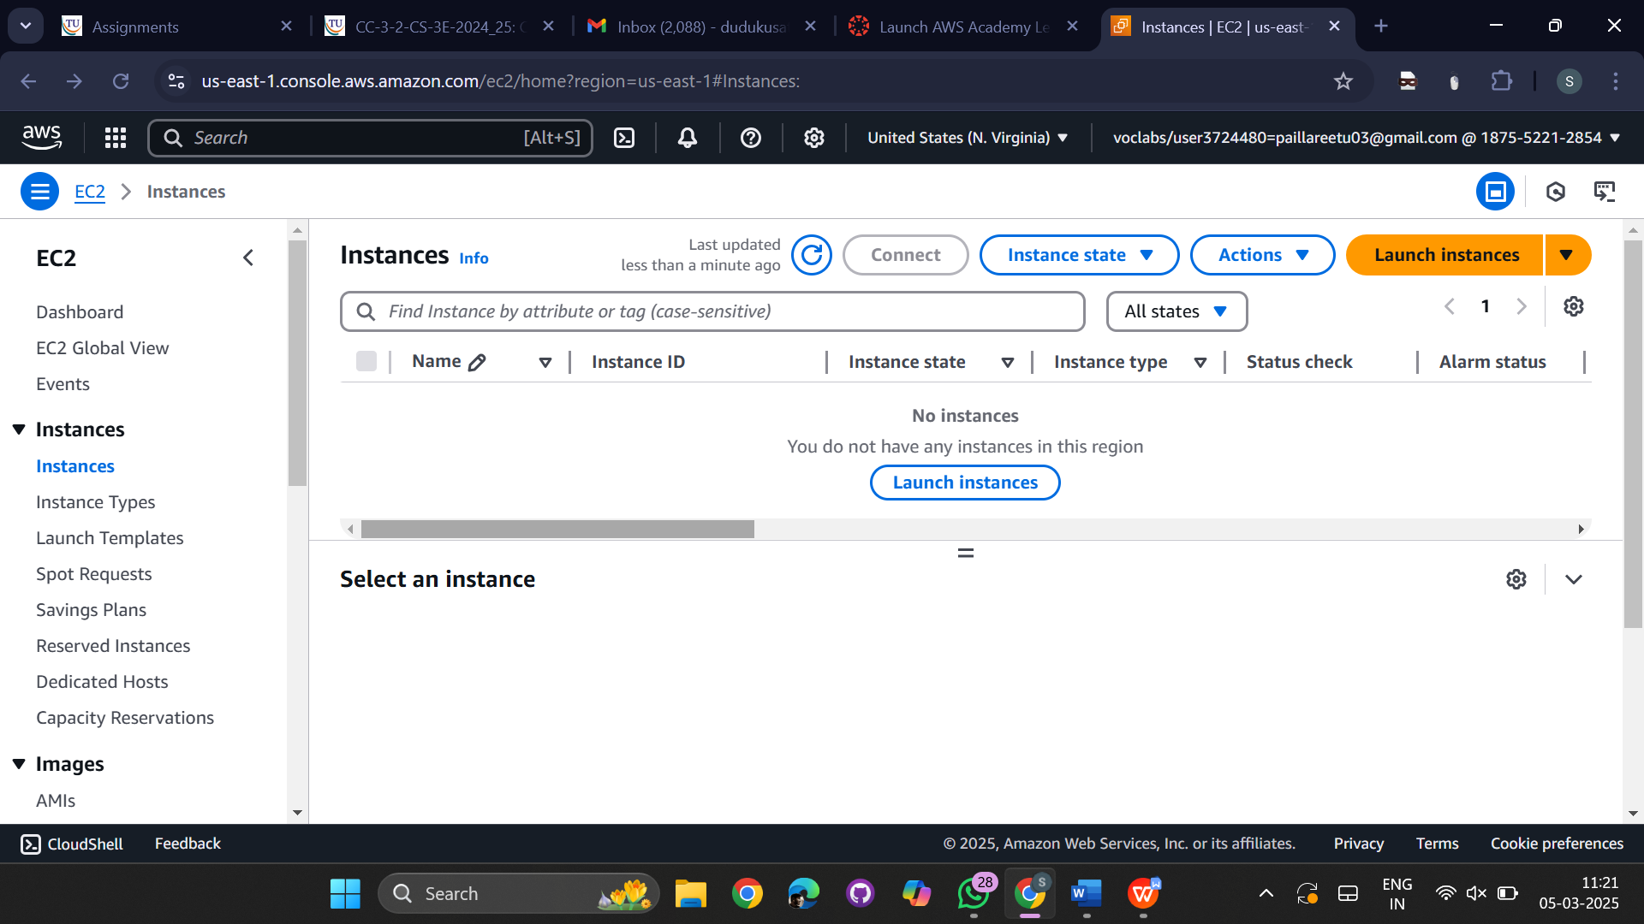

Create an instance with unique name  
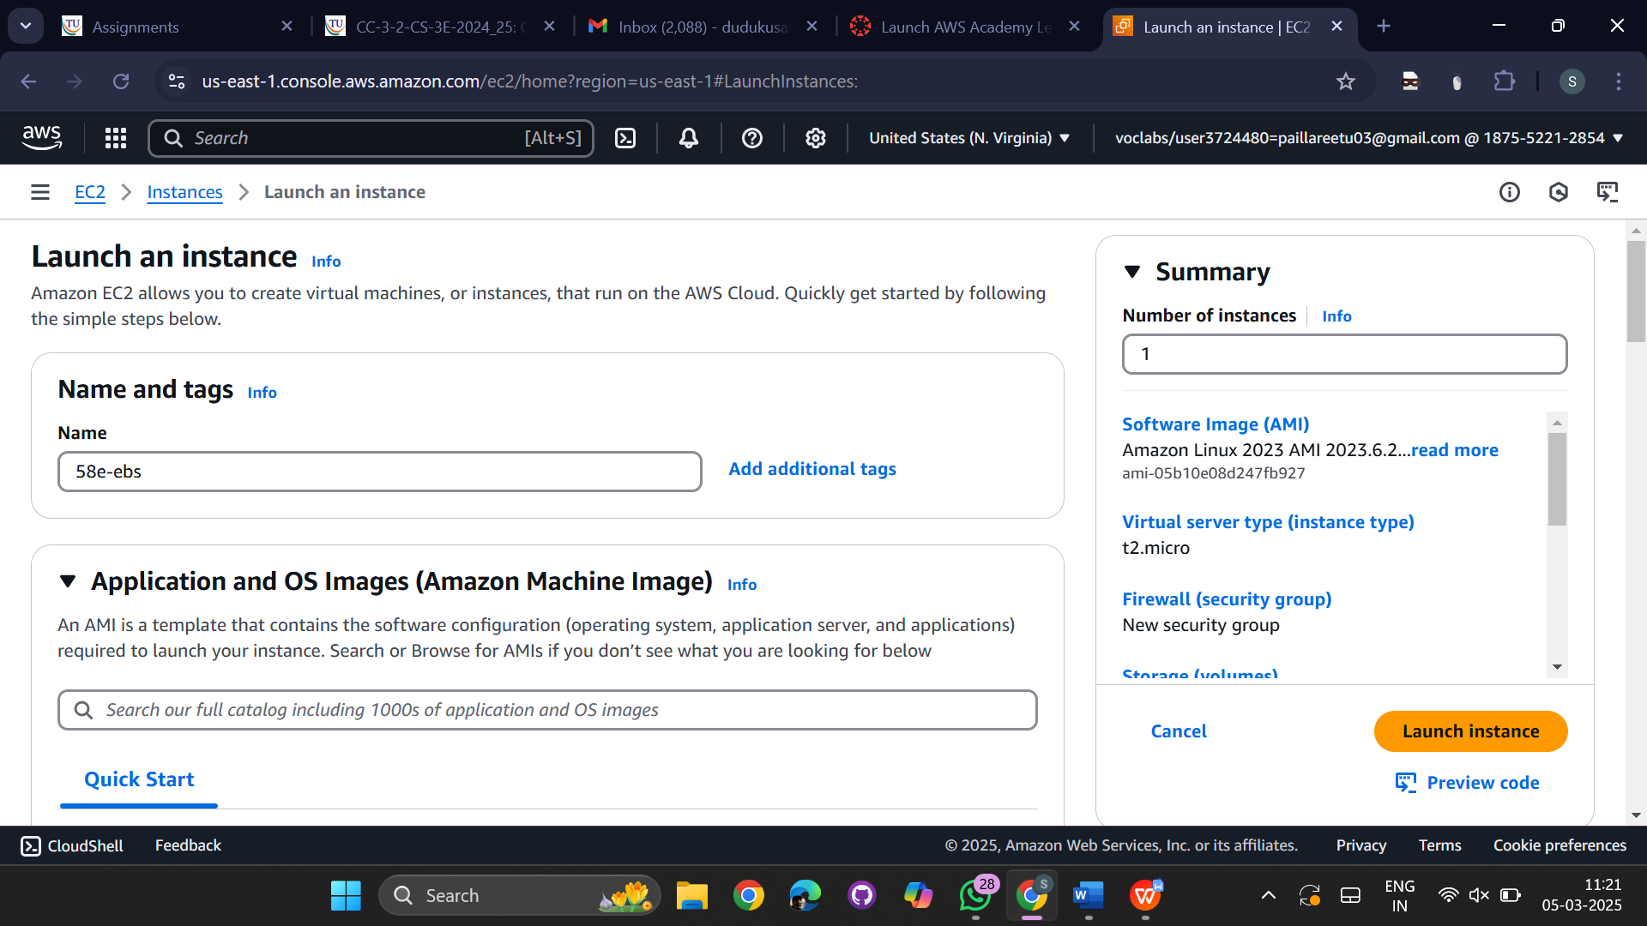  
choose a key pair   
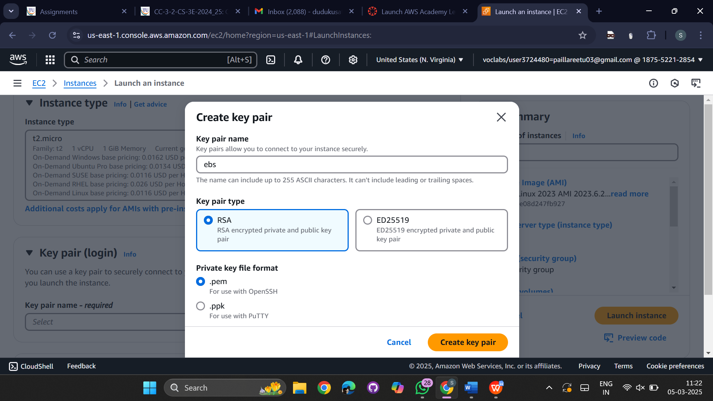

Create new configuration storage volume and change it to 20  
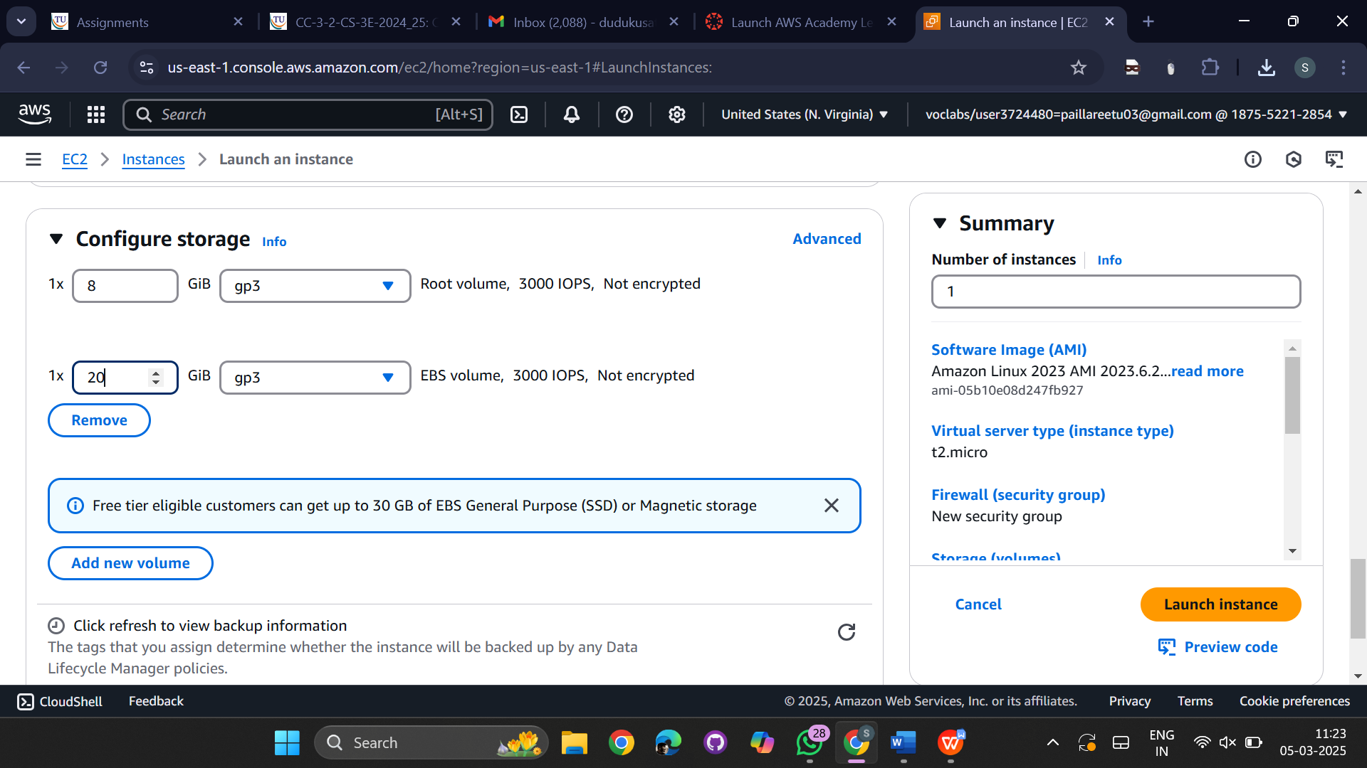

Now successfully instance is created.  
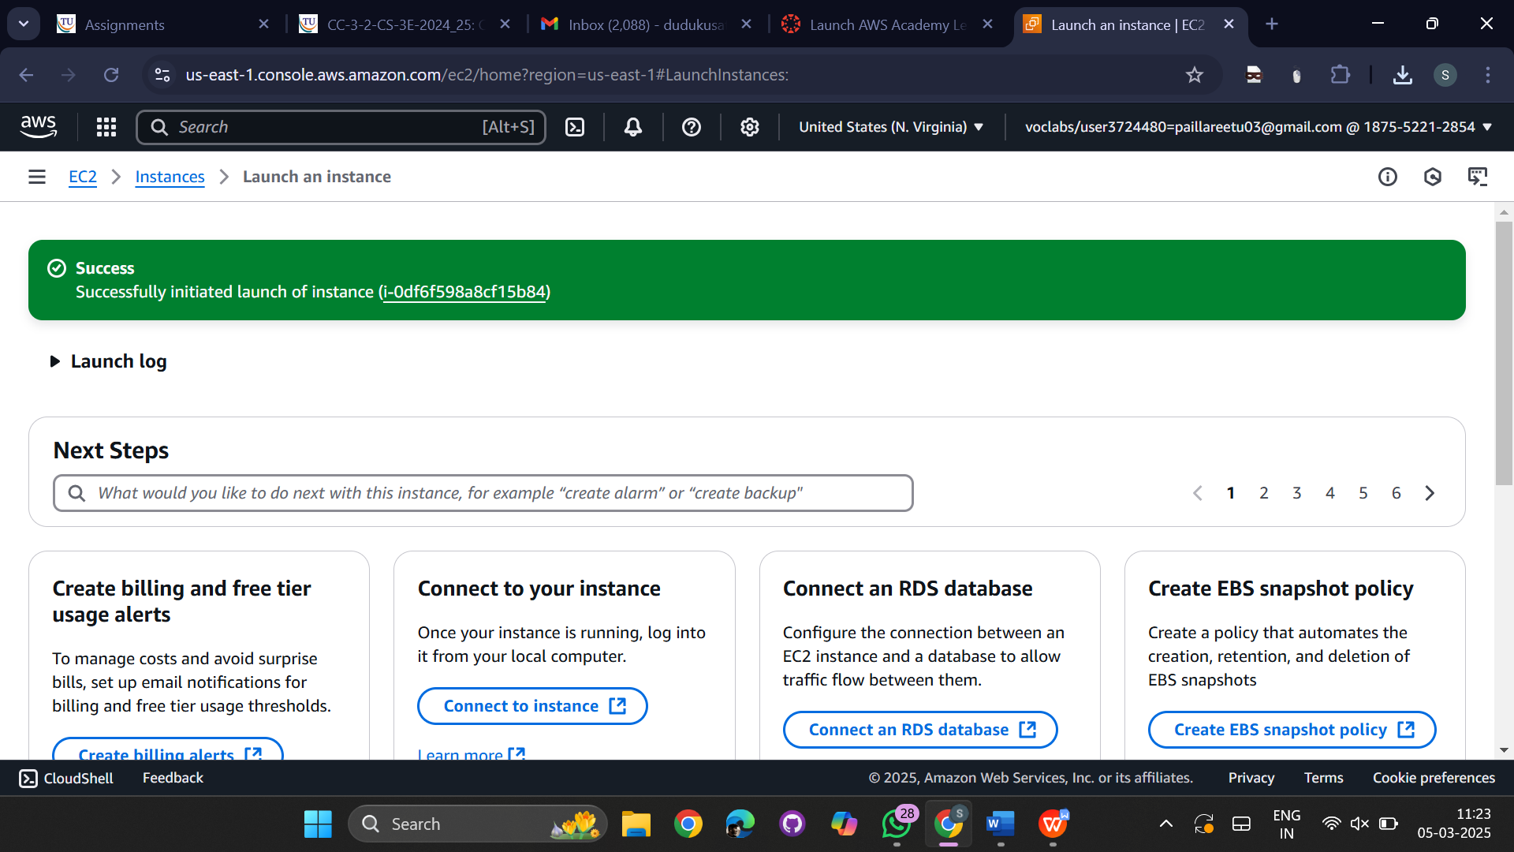

now go to instance and select the instance which we created recently and stop the instance  
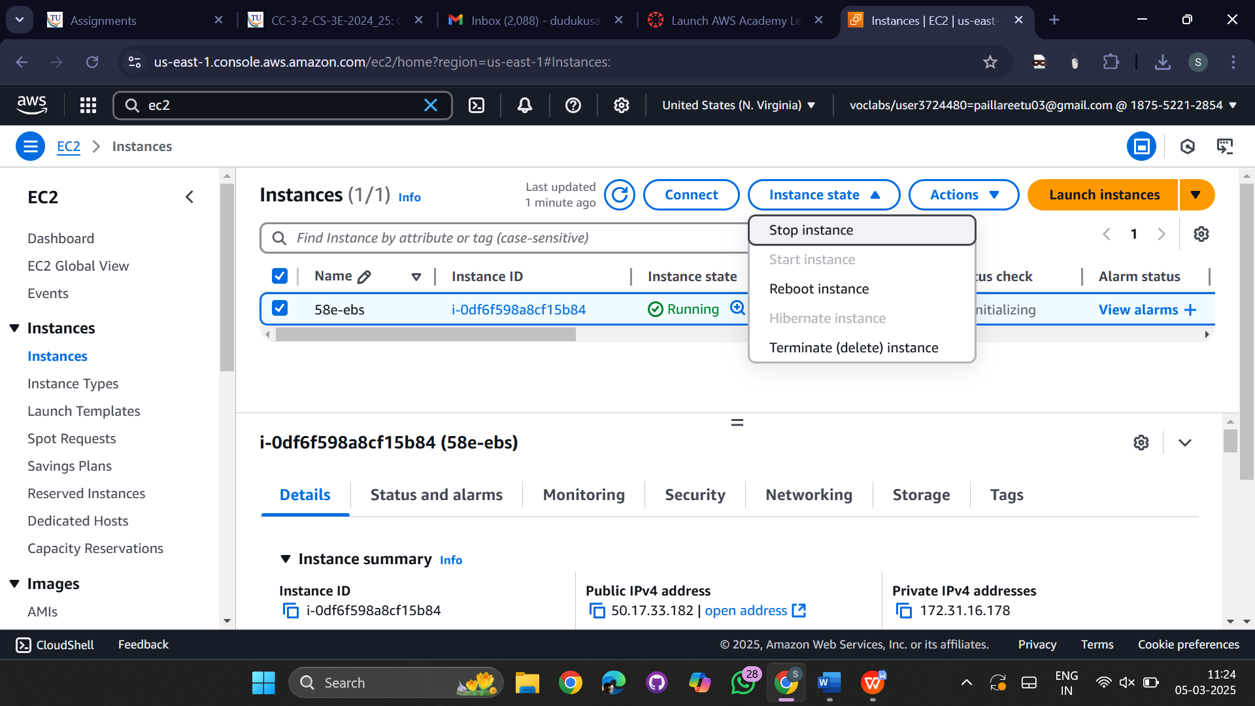

Successfully instance is stopped  
  
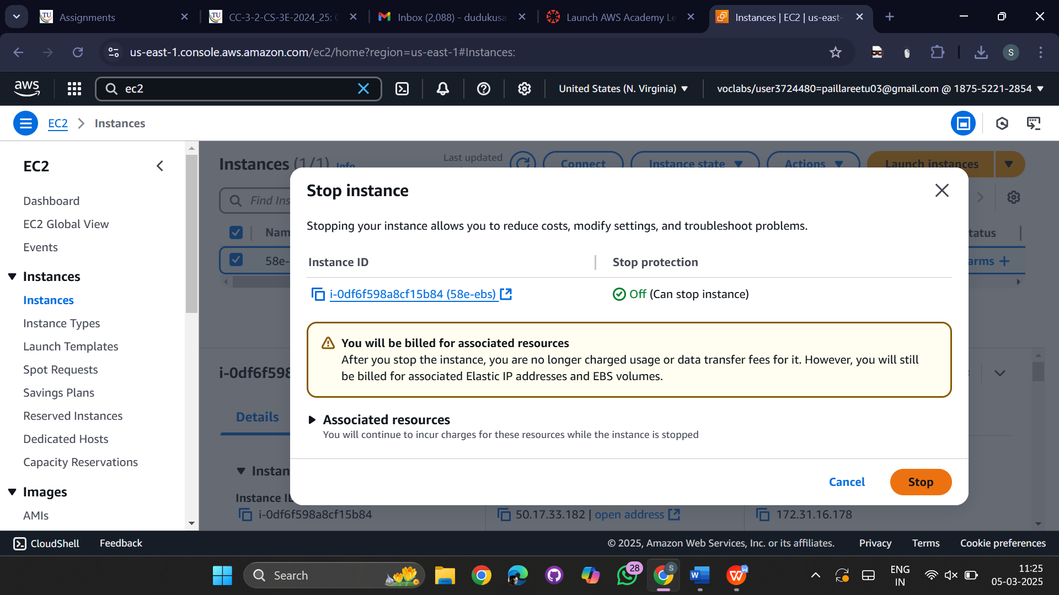

Go to actions select instance settings and select change instance type

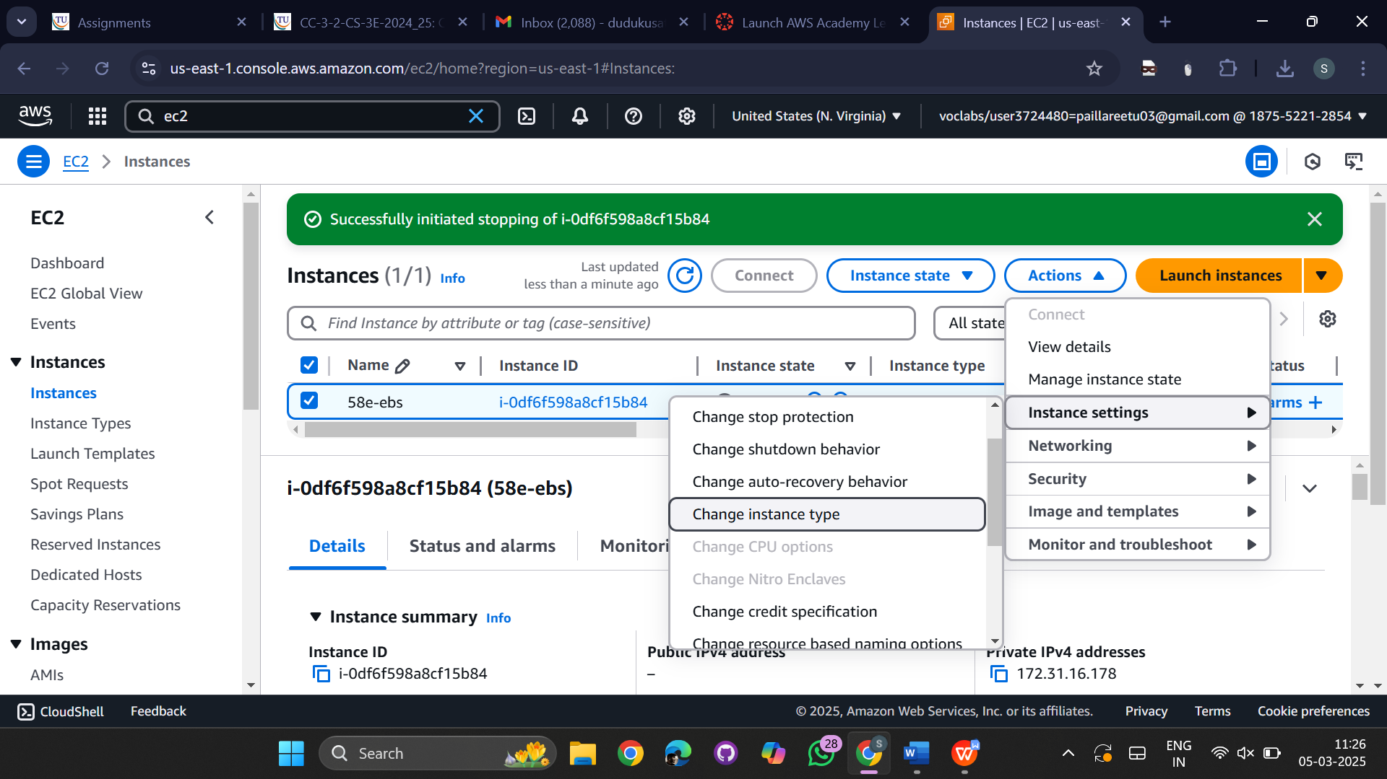

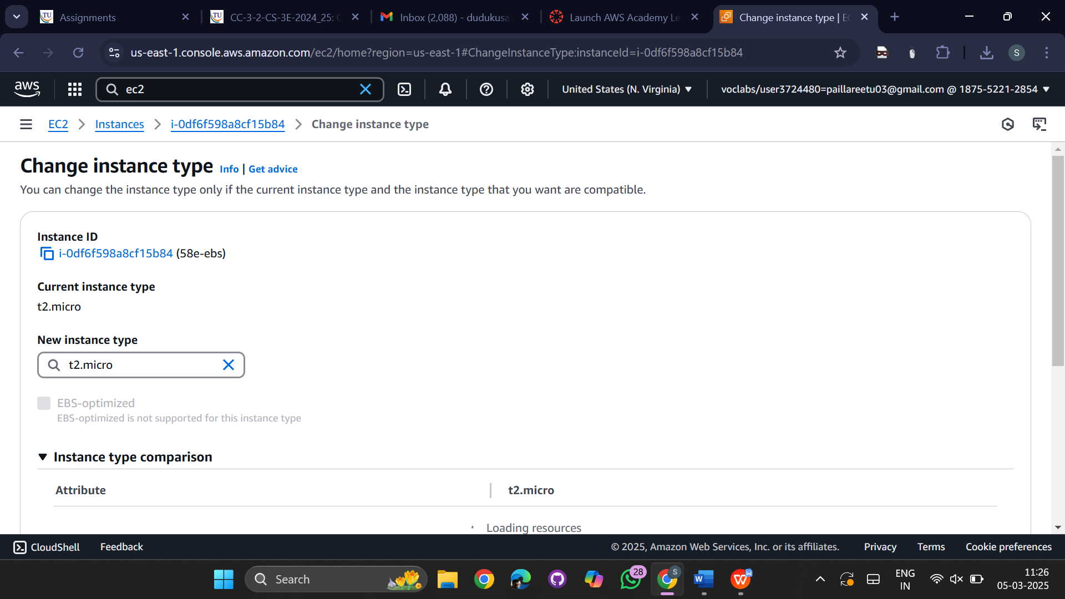

Change the instance type to t2.micro to t2.medium  
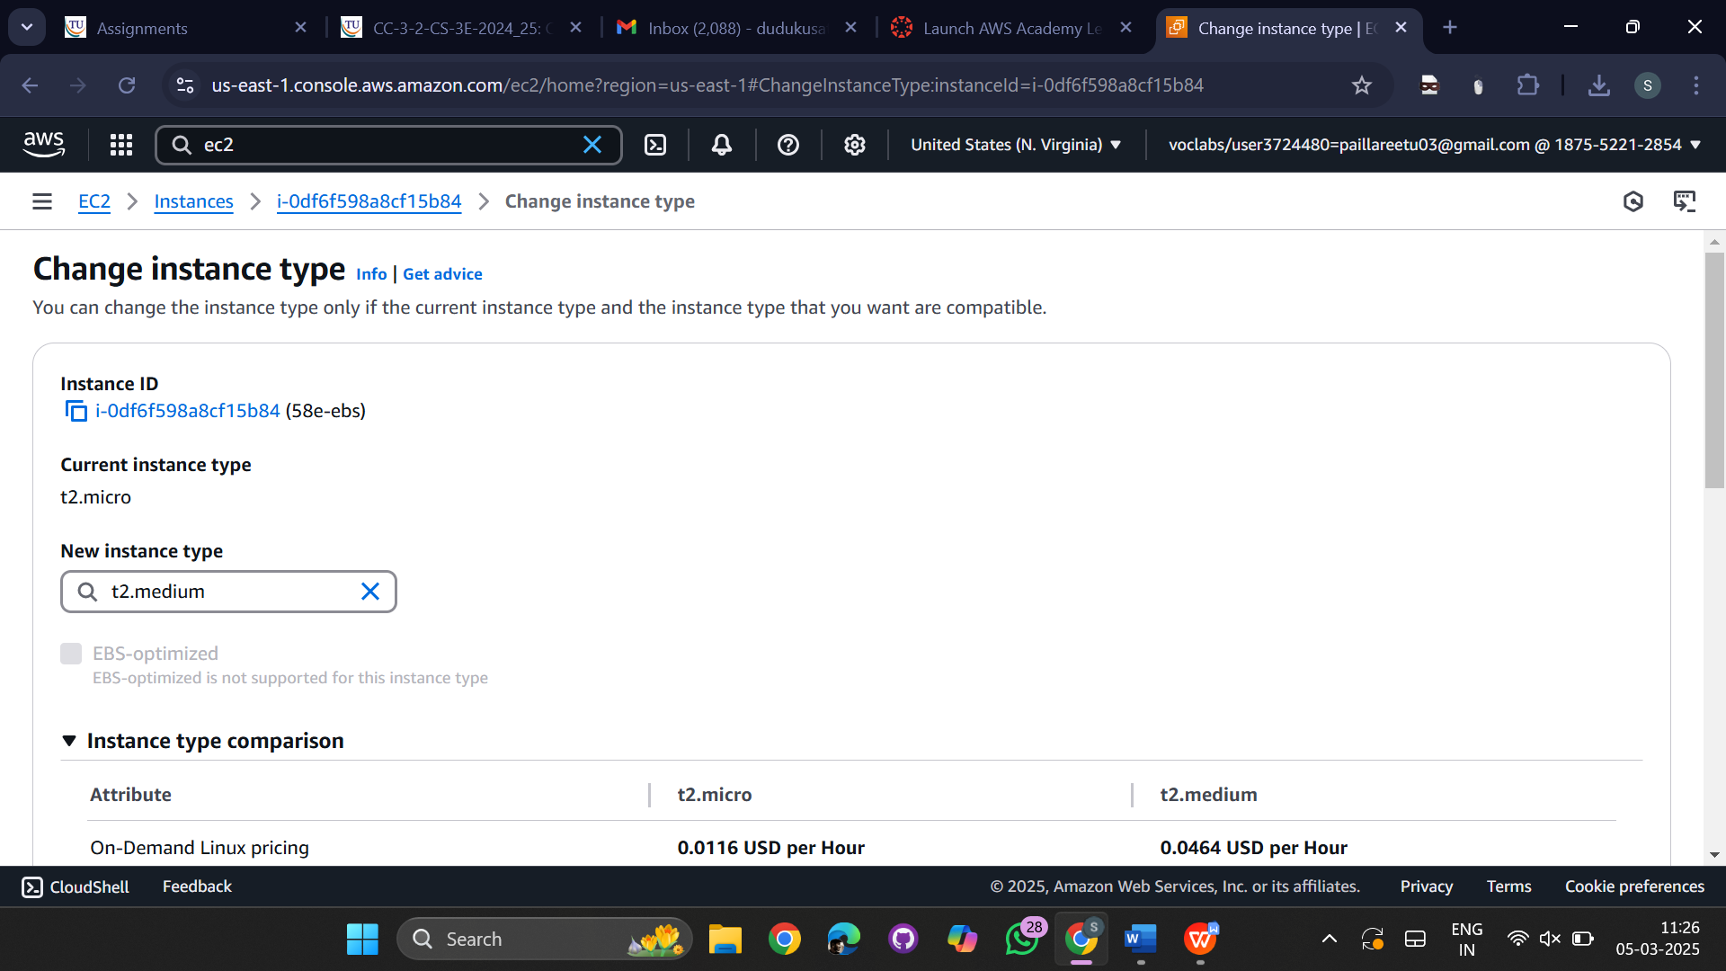

Now successfully instance type is changed  
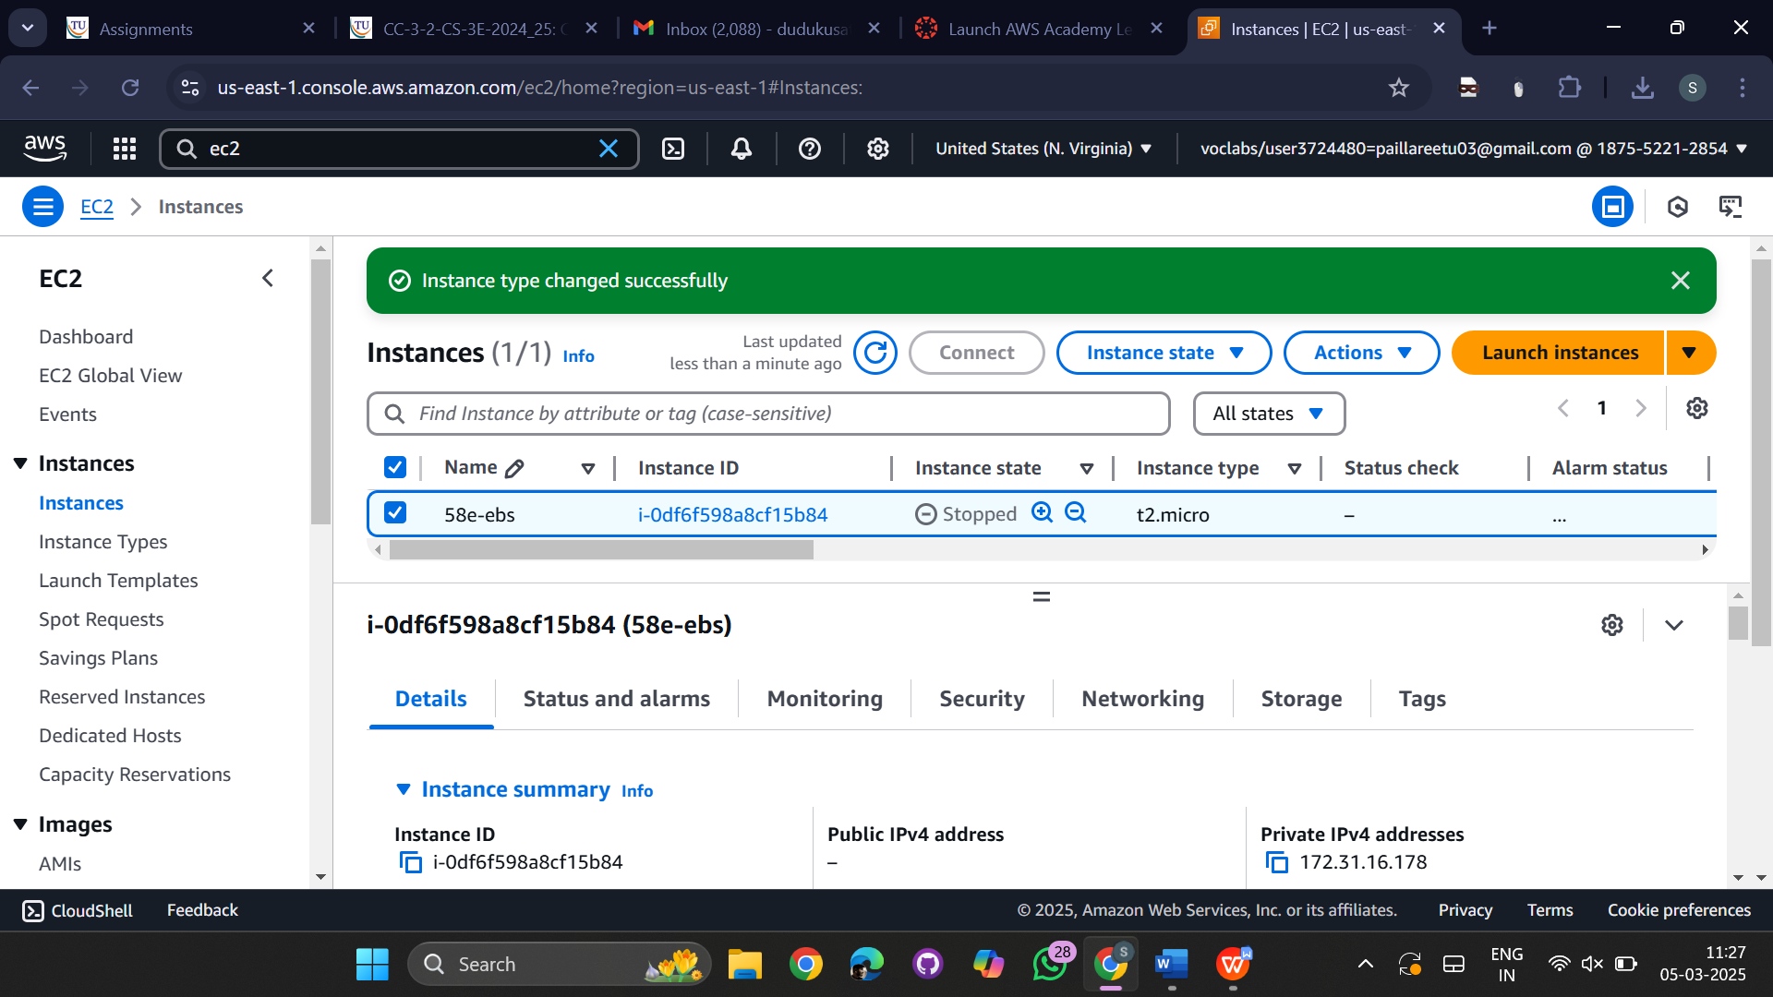  
now click on connect 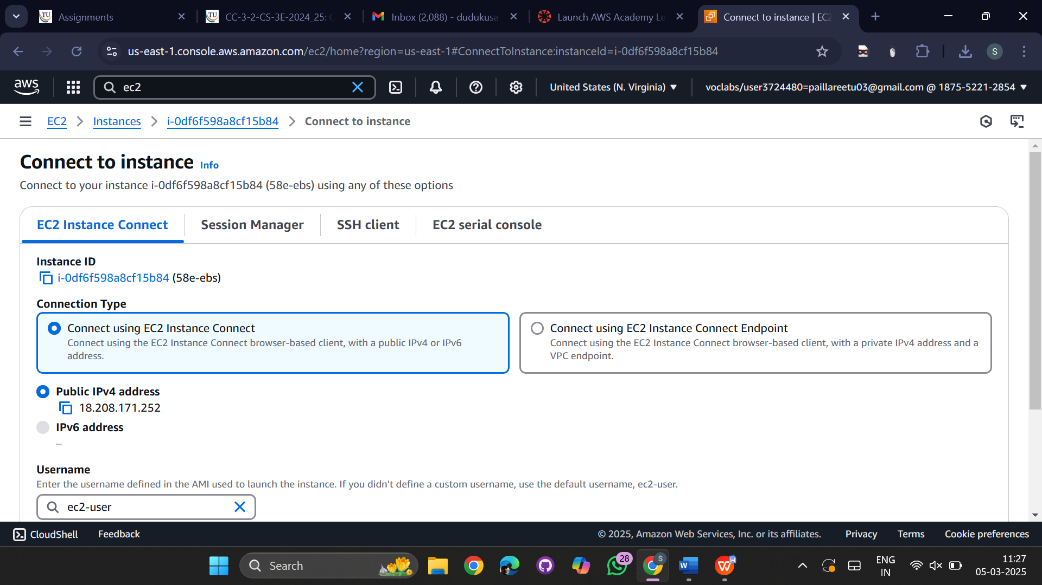

Shell will be opened  
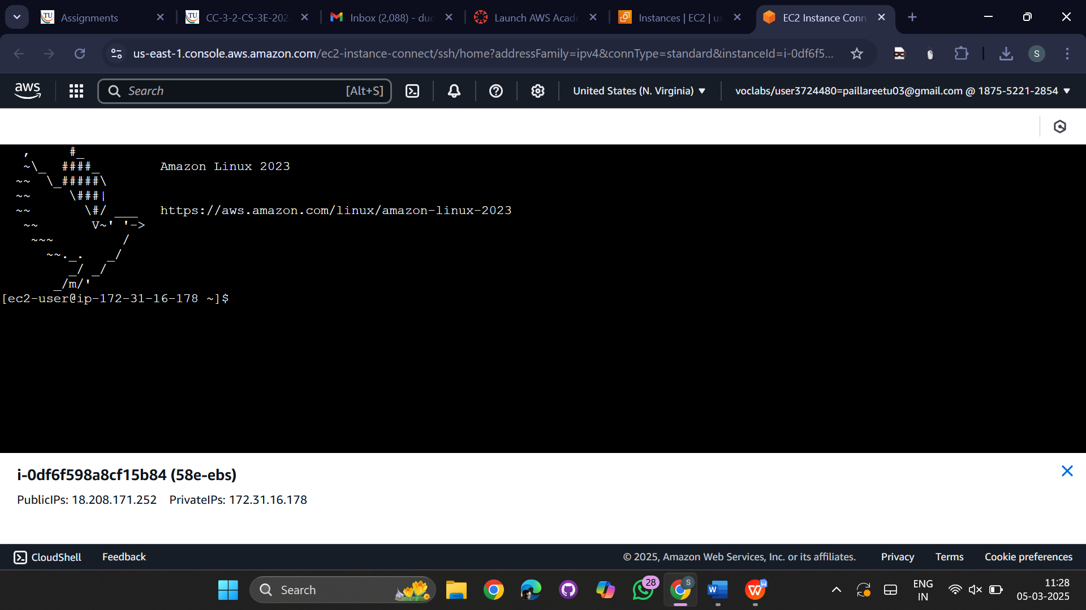

Run the command

-> sudo su  
->lsblk  
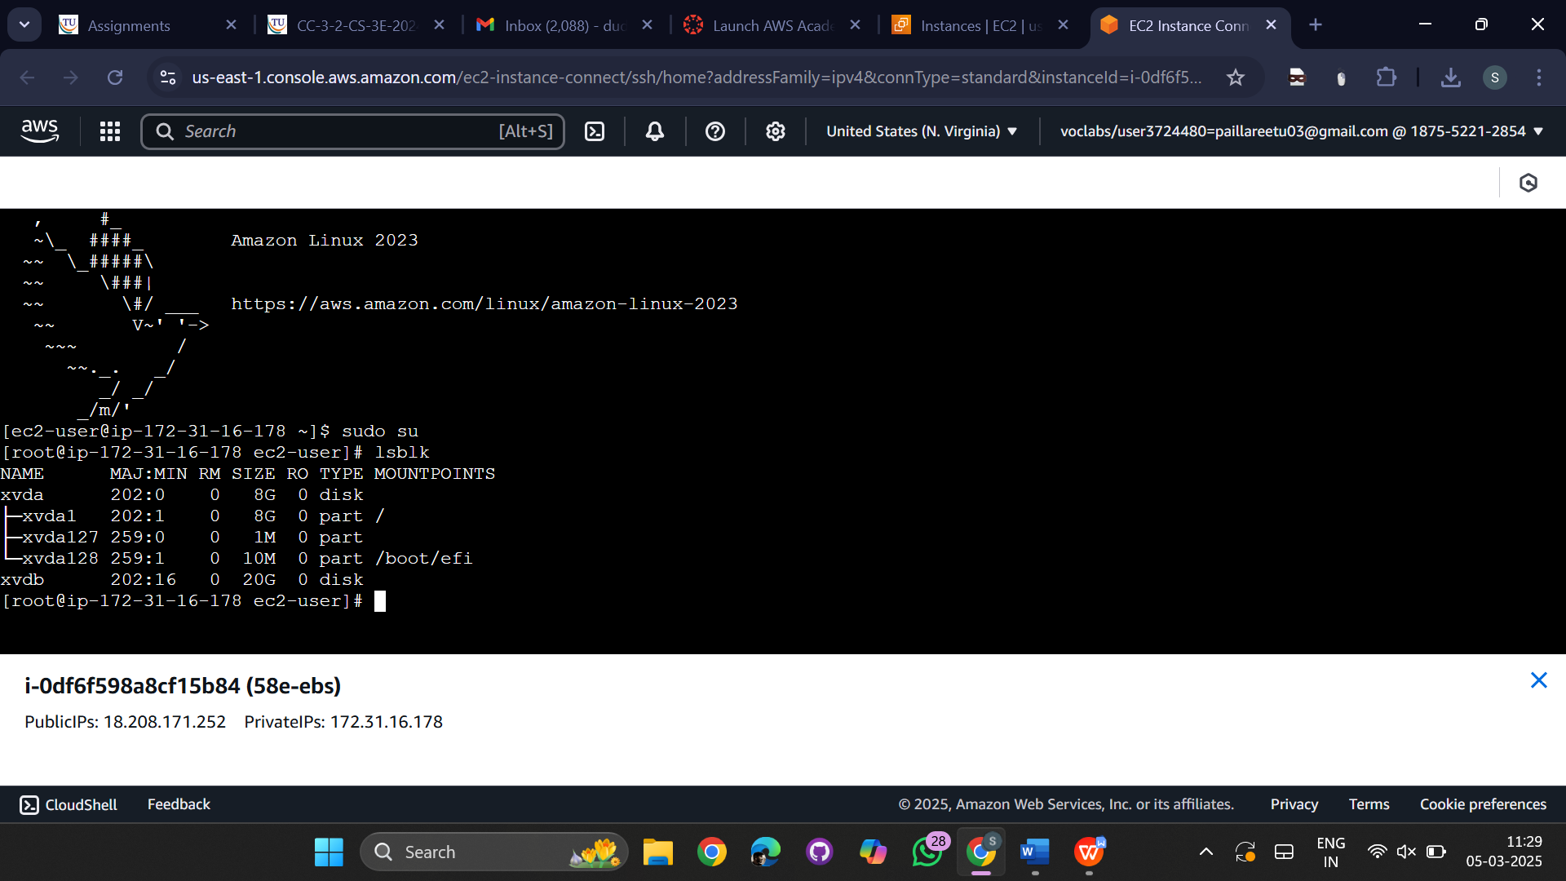

Run the command

->fsdisk -l  
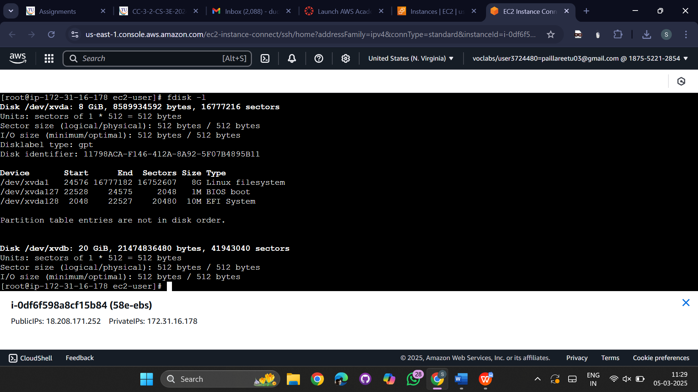  
run the command

->tdisk  
  
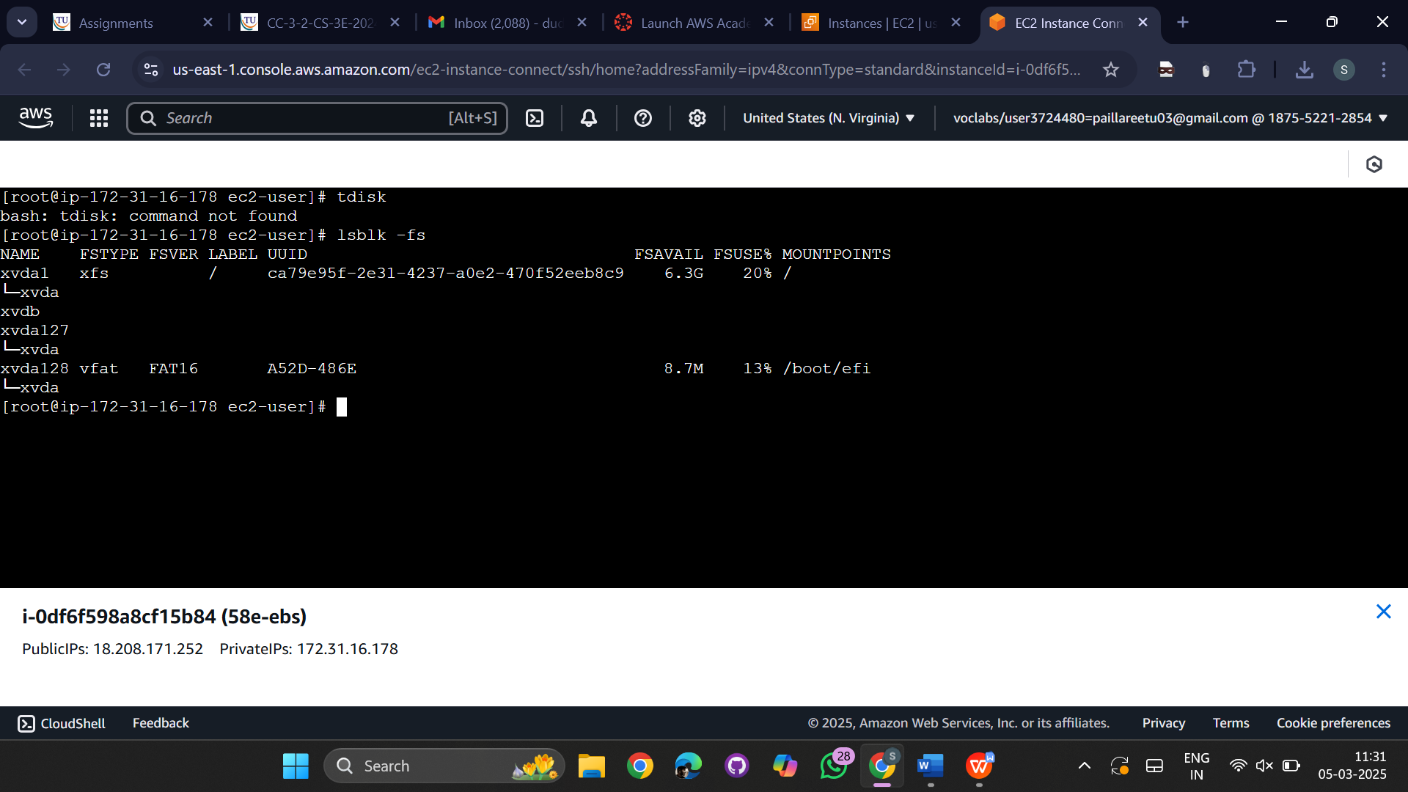

Now create a new instance with unique name  
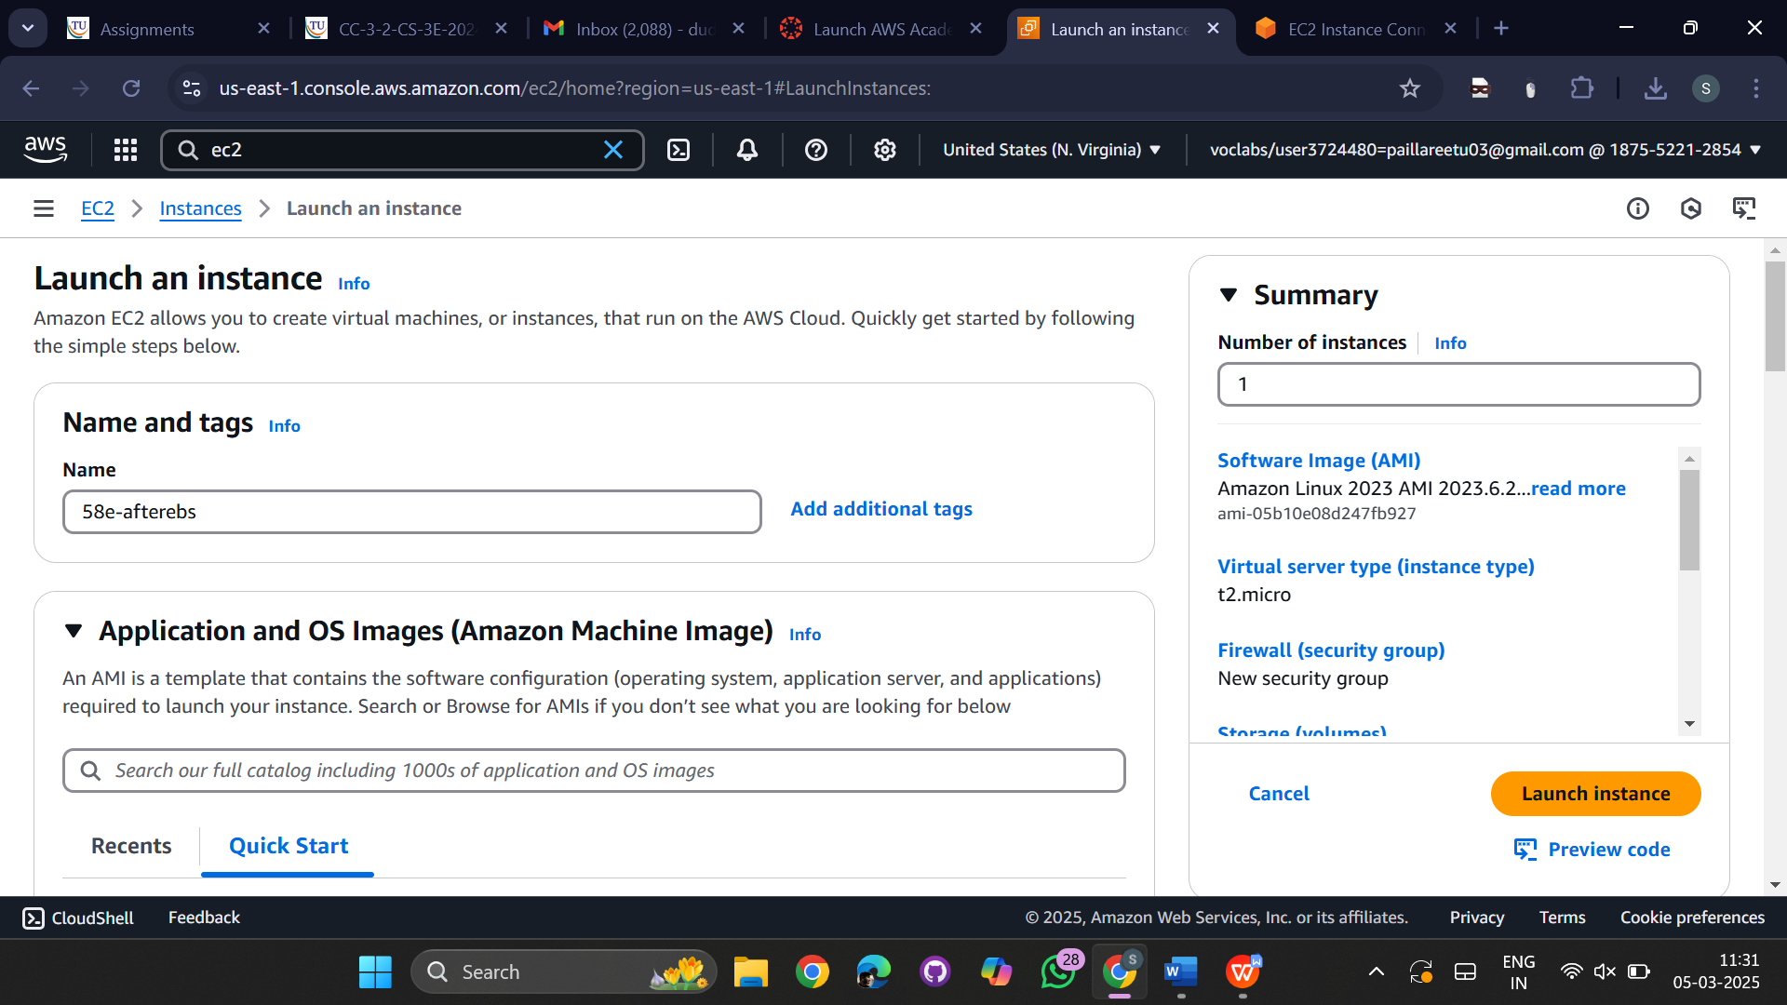

Select key pair  
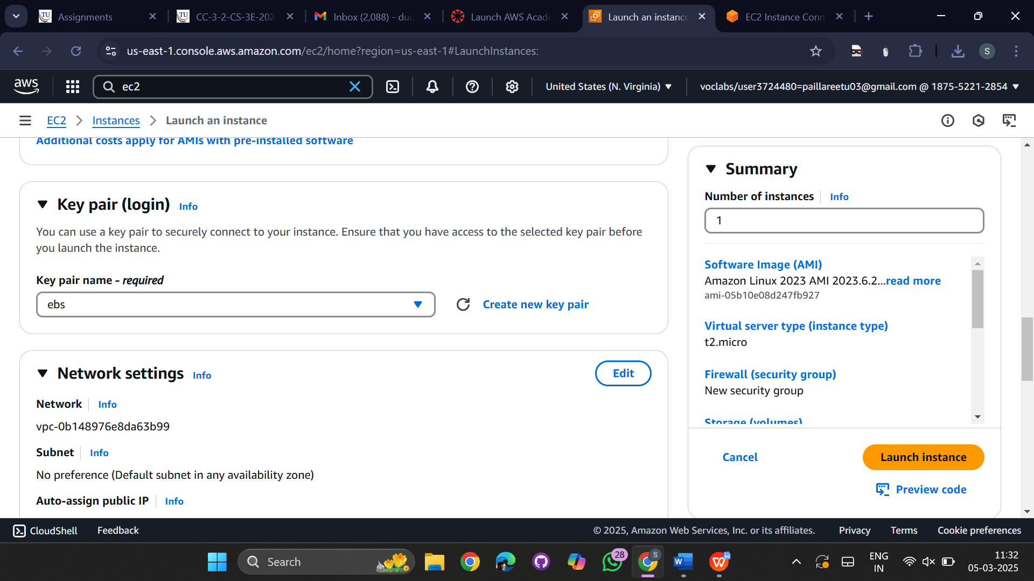

Go to volumes section under Elastic block storage  
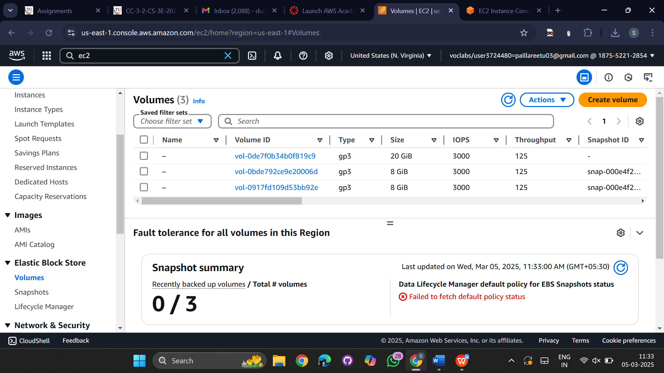

Now click on new volume and change the size to 35(GiB)  
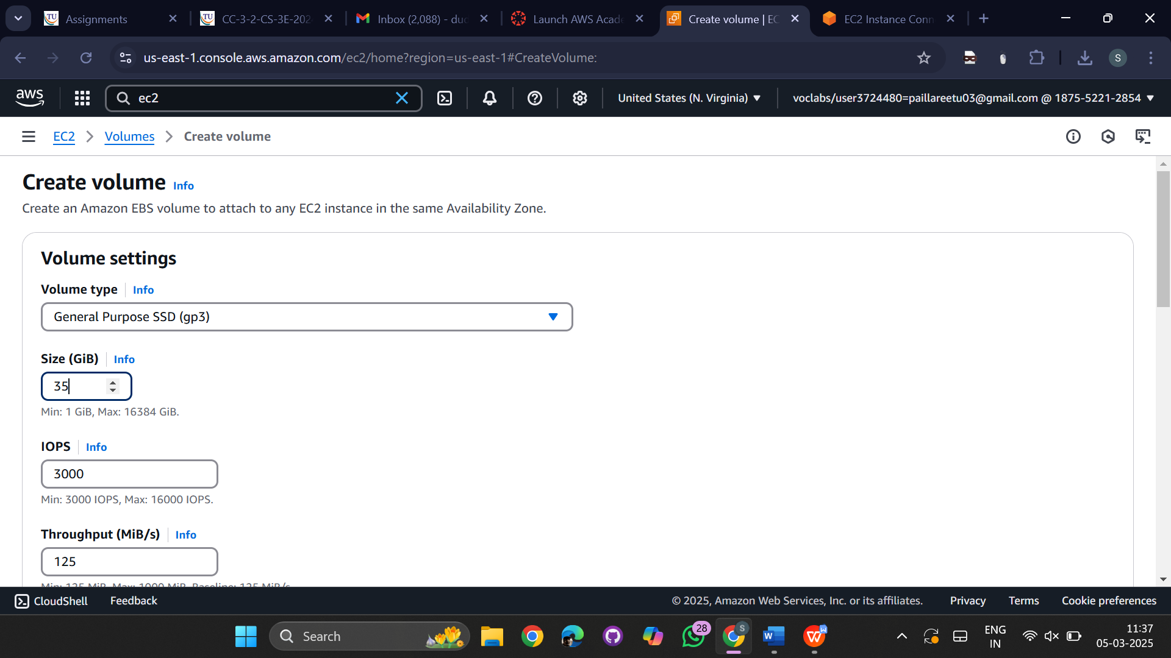

Change the availability zone if the instance is in another region

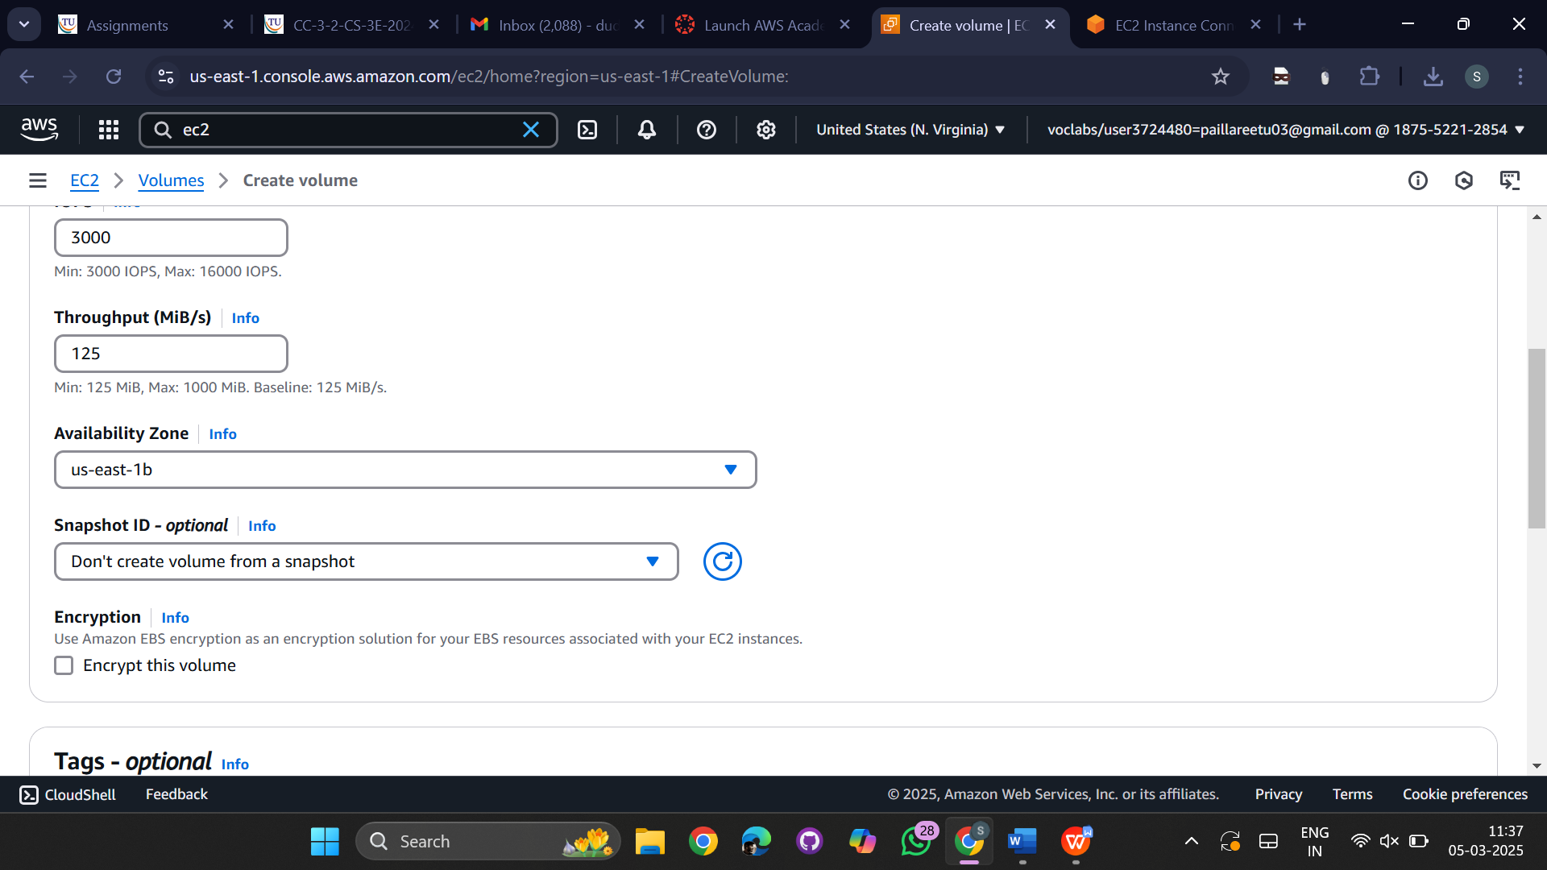

Successfully volume created  
  
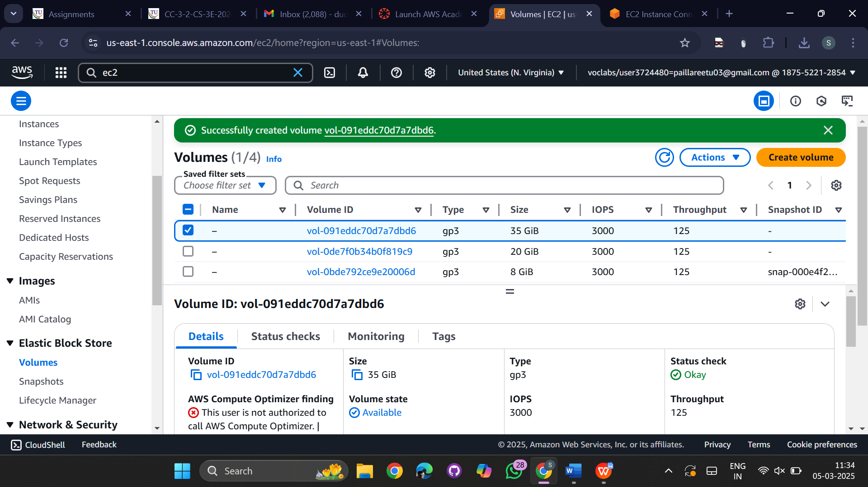

After creating volume go to actions and select attach volume  
choose instance in instance type block  
choose device name to /dev/sdb  
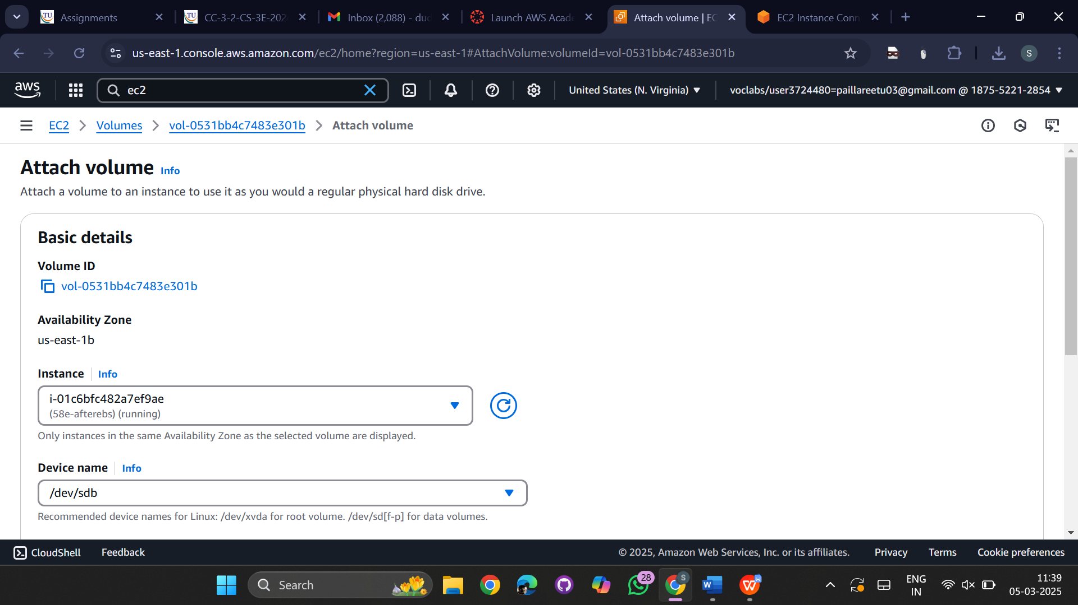

Now go to instance and select the instance and click on connect  
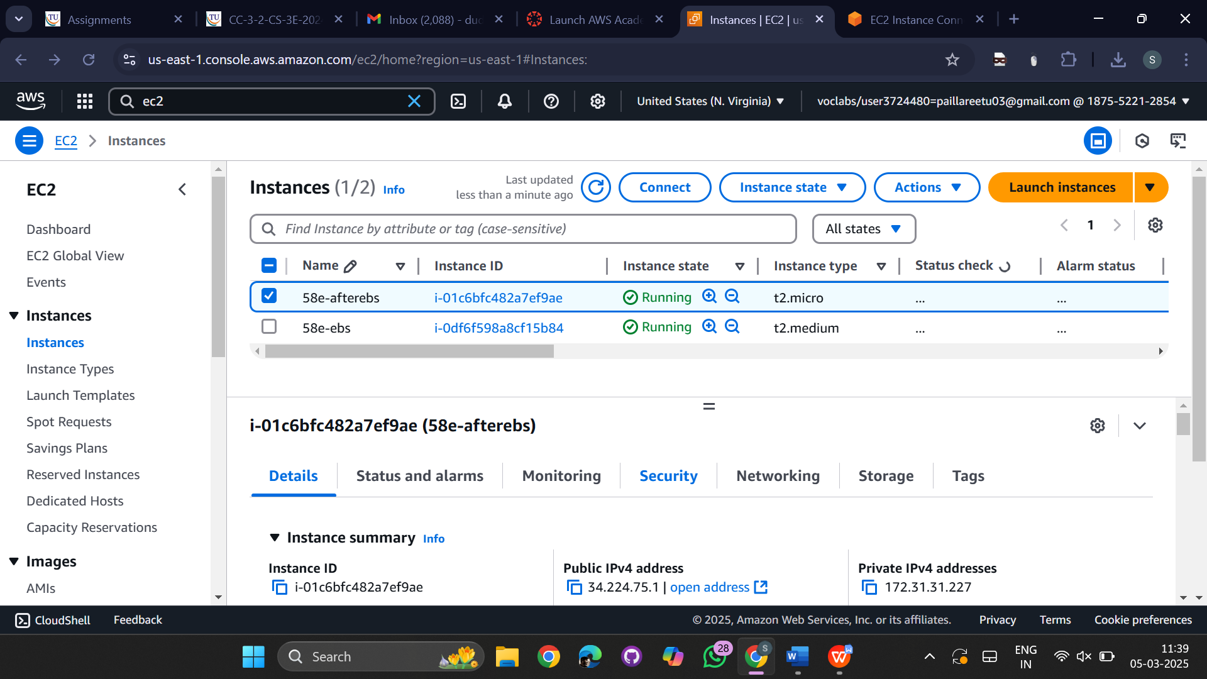

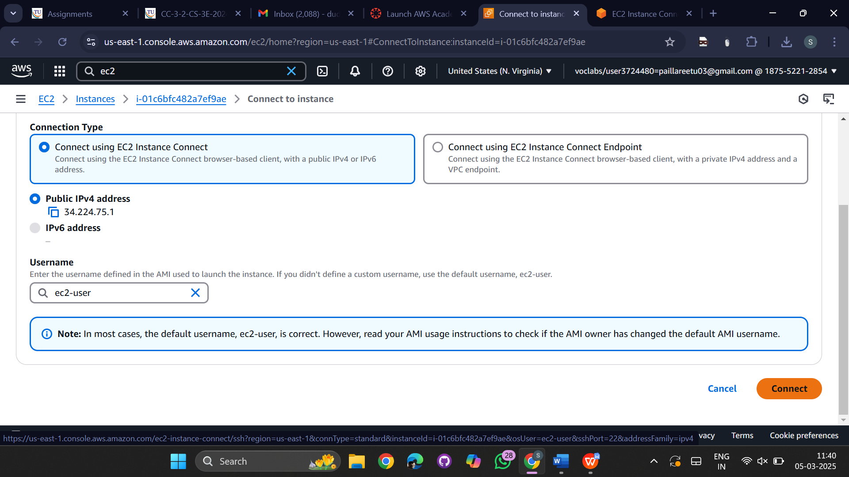

Shell will be opened  
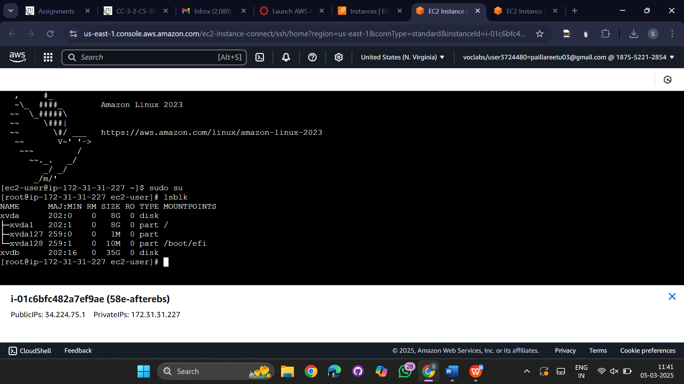

sudo su: for super user  
lsblk – listing the blocks

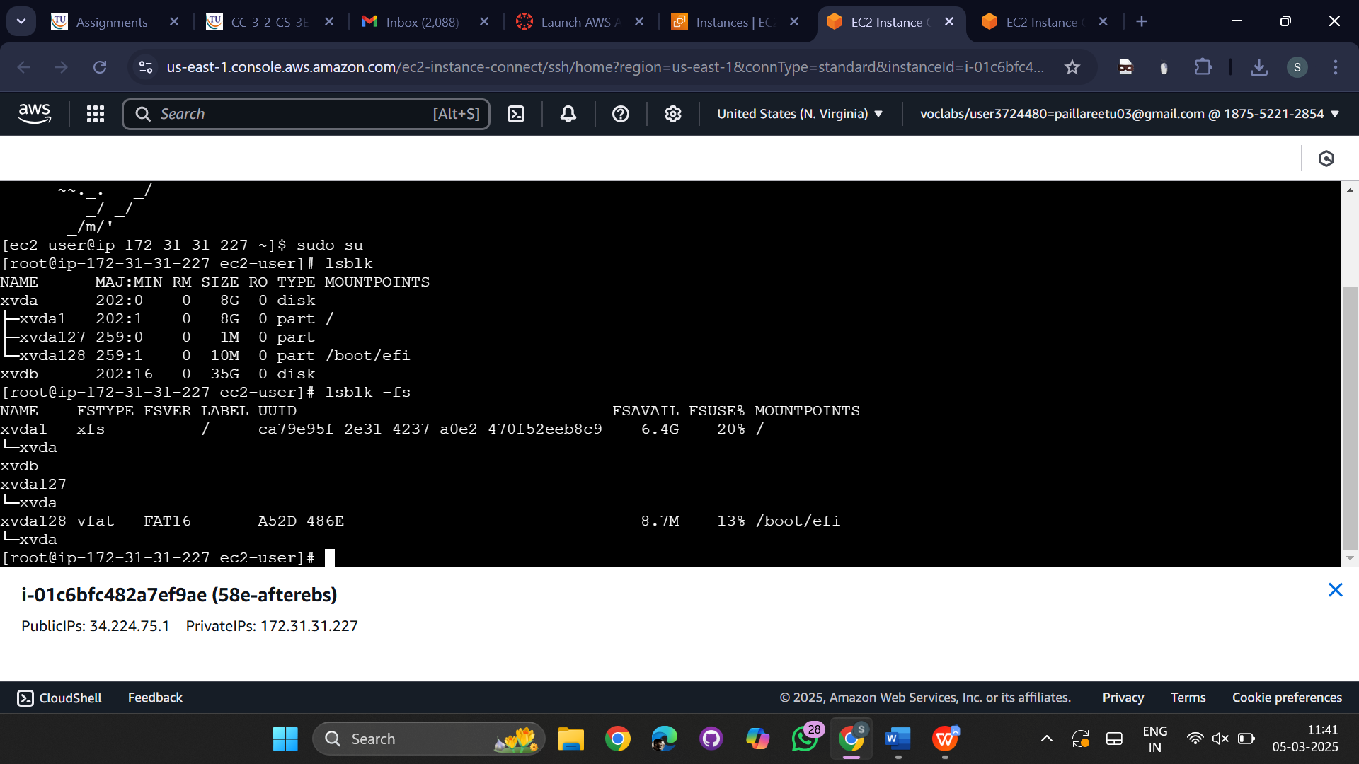  
fdisk -l

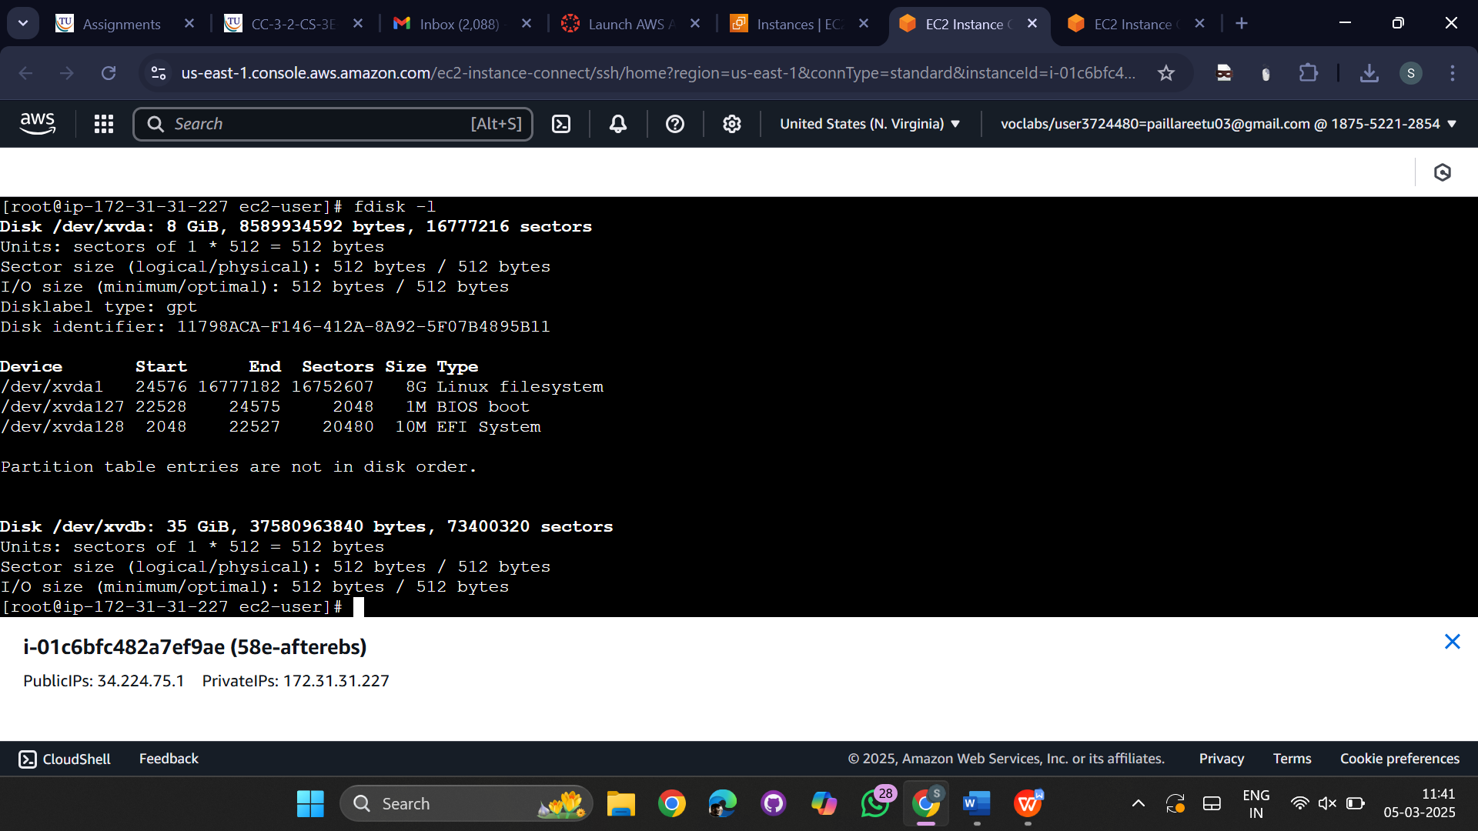

Create a partition using **fdisk**:

fdisk /dev/xvdb

* + 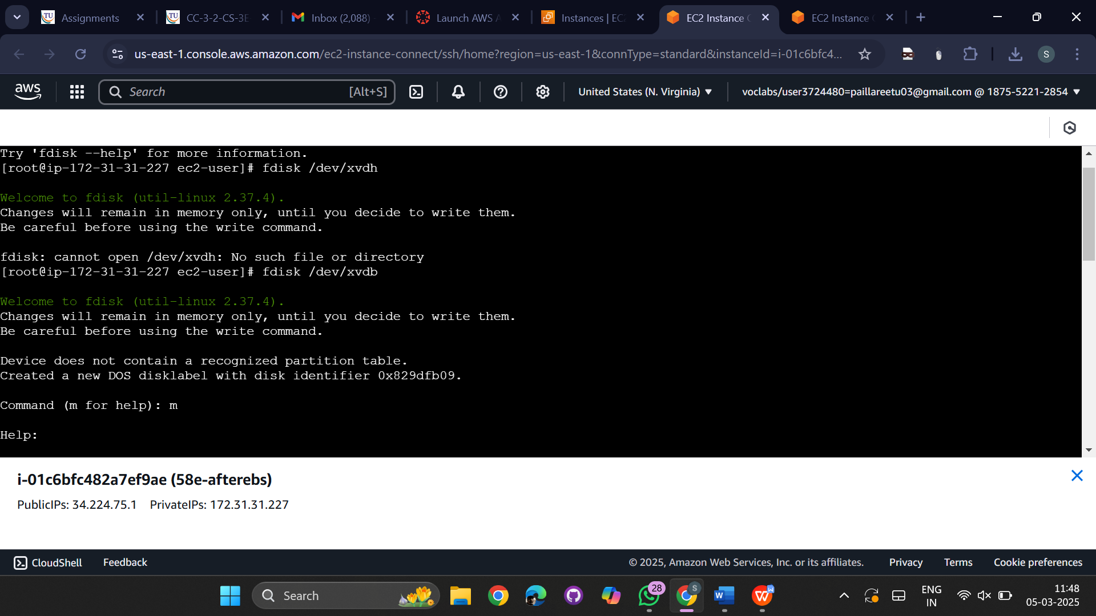  
    Press **m** → Show help menu
  + Press **n** → Create a new partition
  + Press **p** → Create a primary partition
  + Press **Enter twice** → Use default partition size
  + Press **w** → Write changes and exit

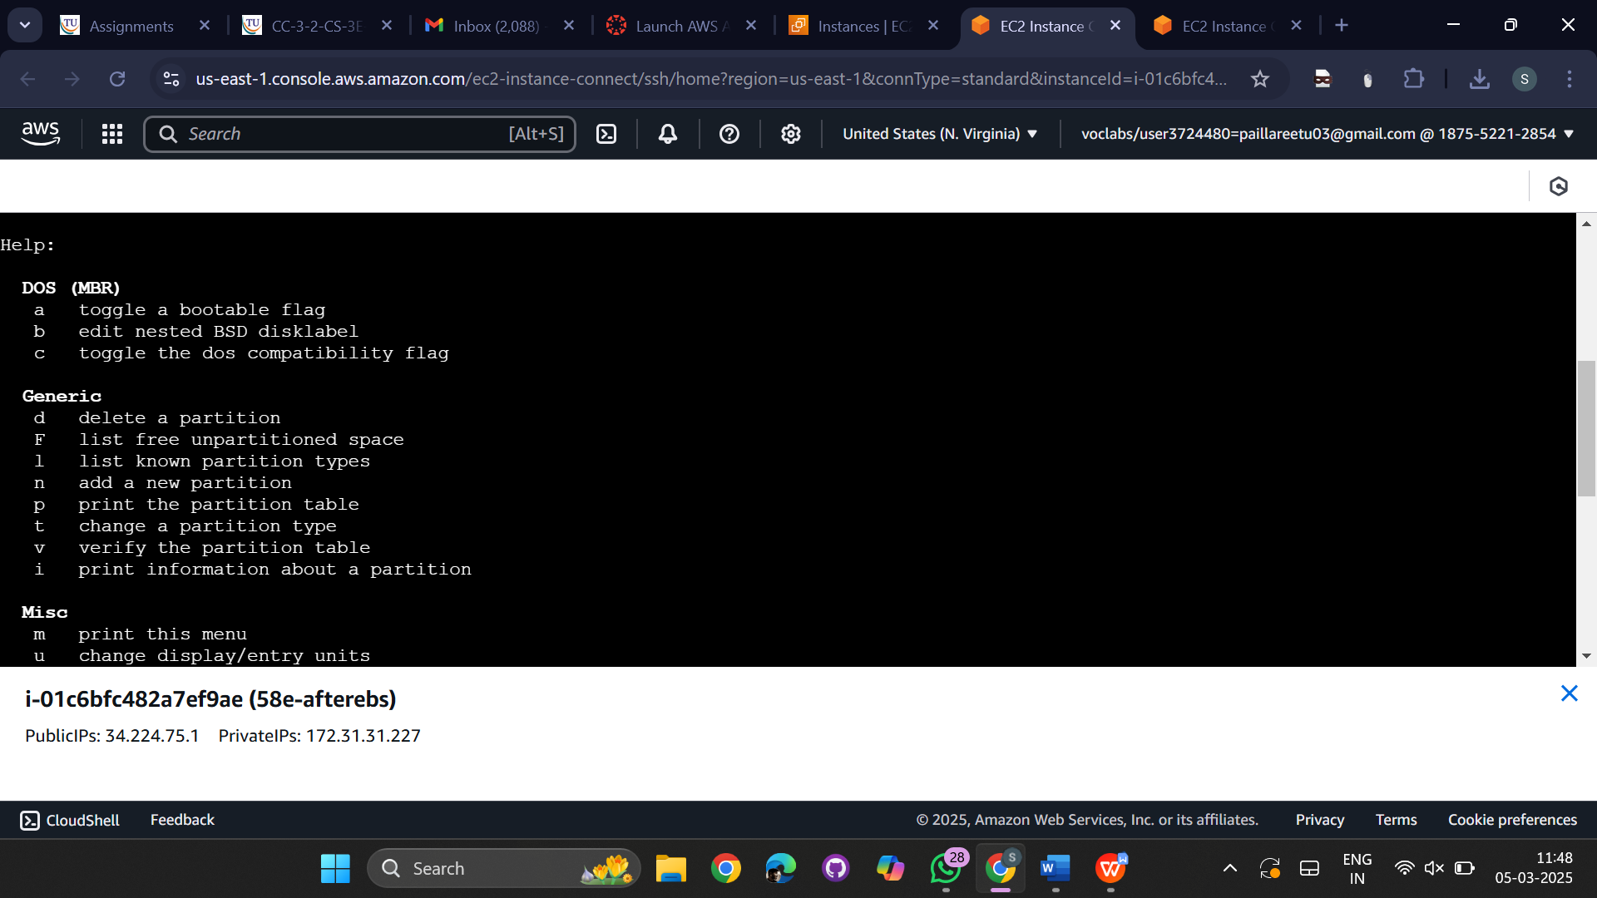

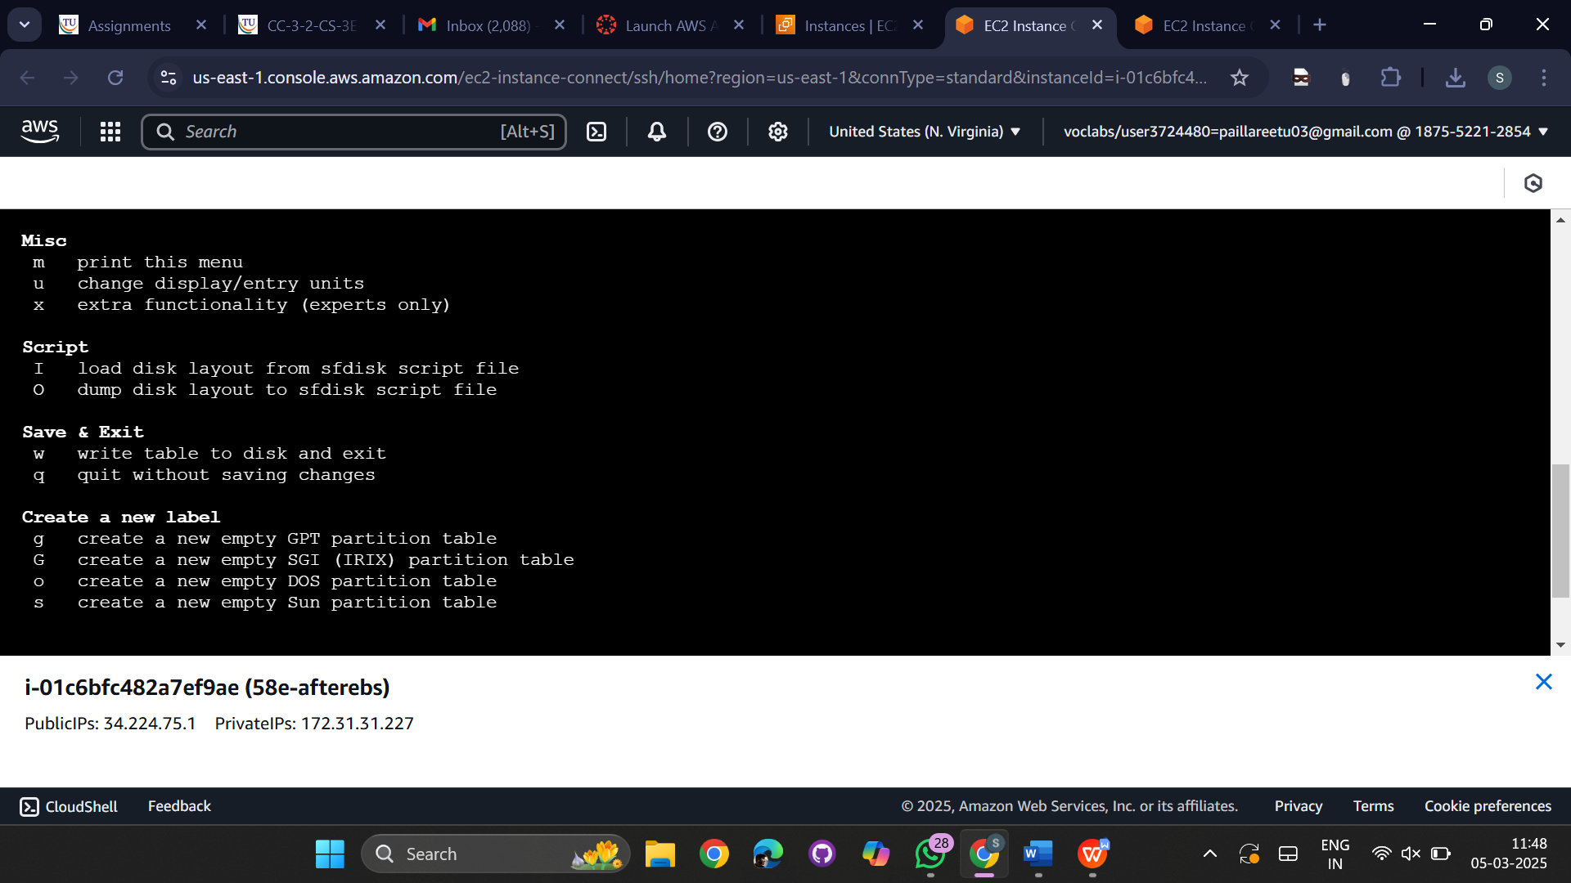  
  
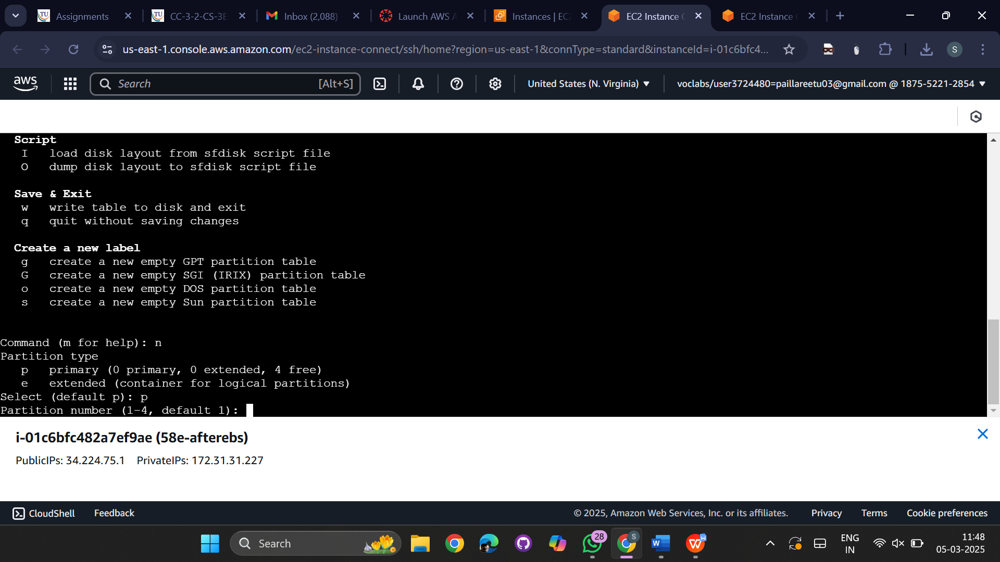  
  
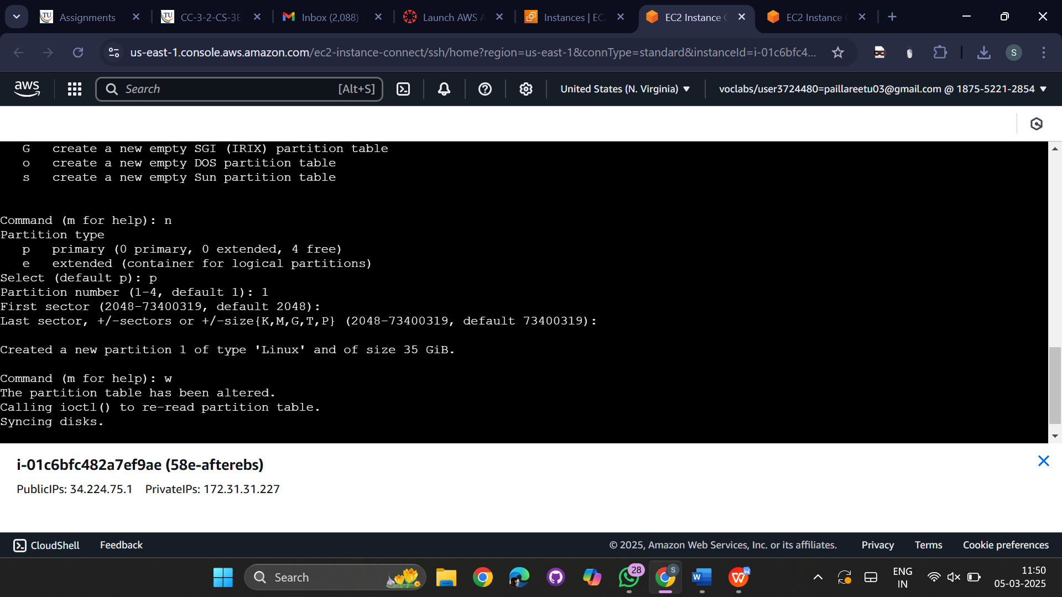  
**Format the Disk Partition**

mkfs.xfs /dev/xvdb1 # For XFS

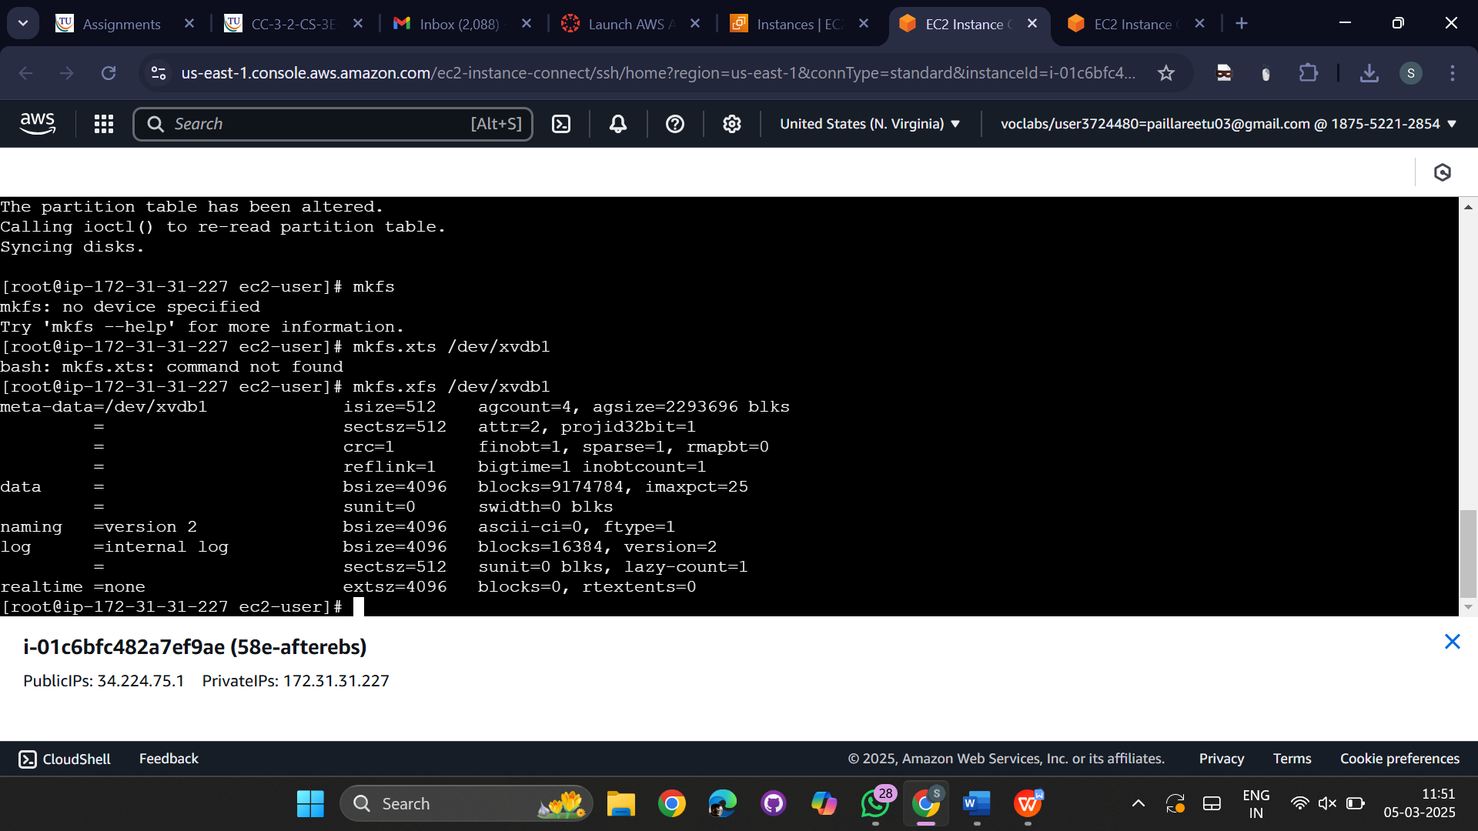

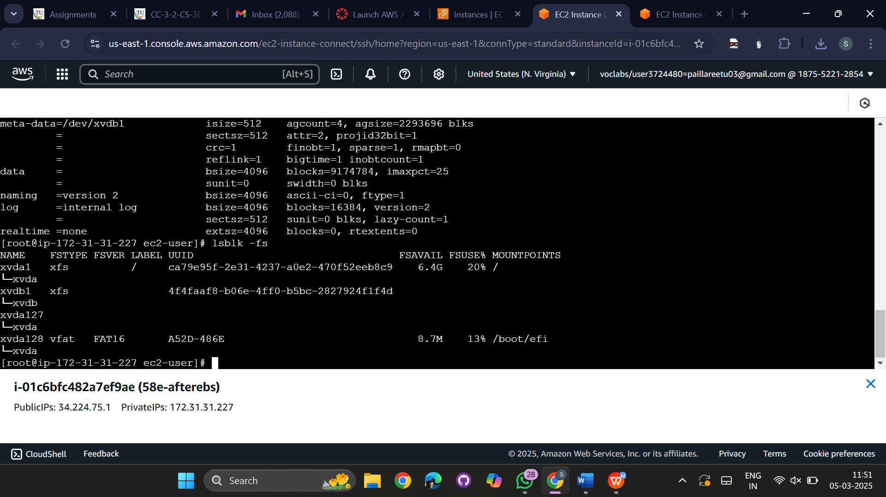  
Create a new directory then mount the /dev/xvdb1 on to it and then add files to the new directory by using ls we can view the files

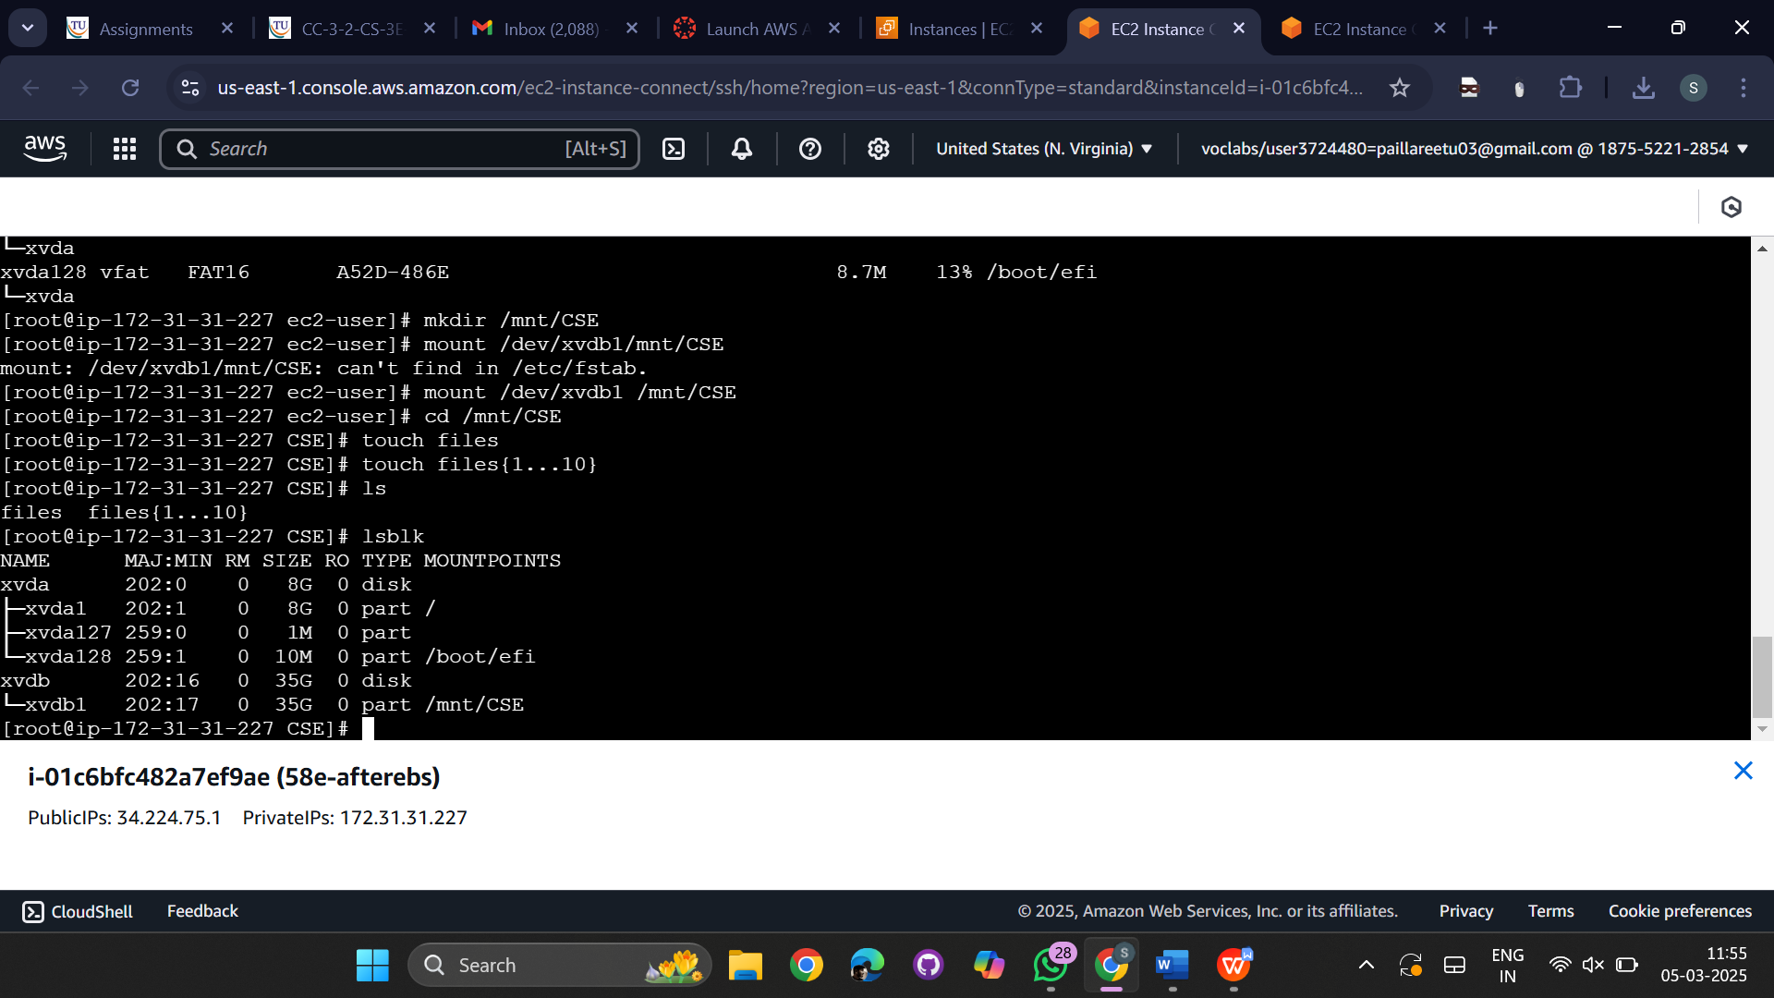

Here we can see that the directory is mounted perfectly

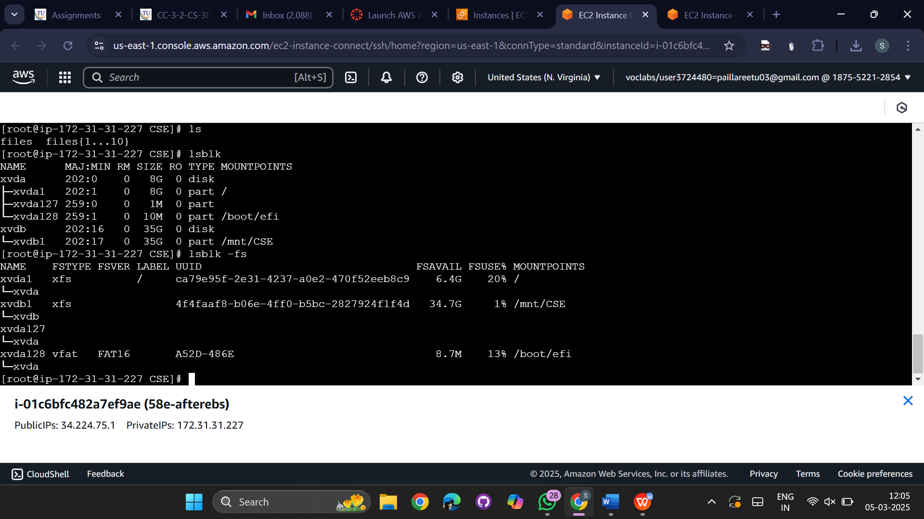

**Persist:**

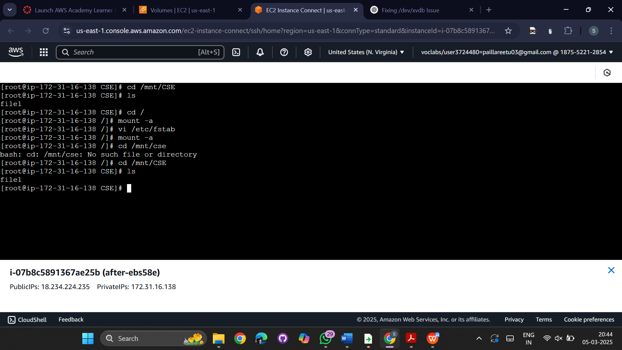  
  
  
  
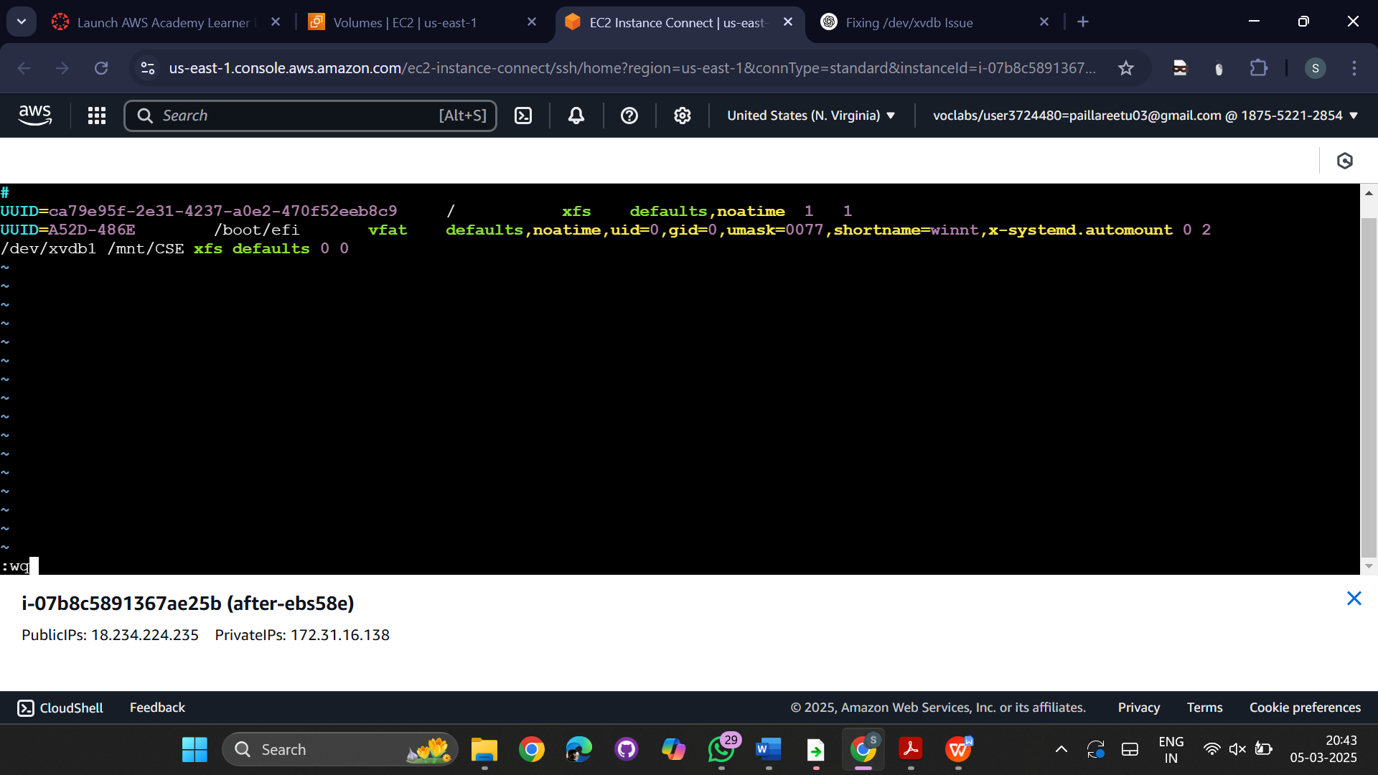

Deattaching the volume  
go to actions and select the detach volume.  
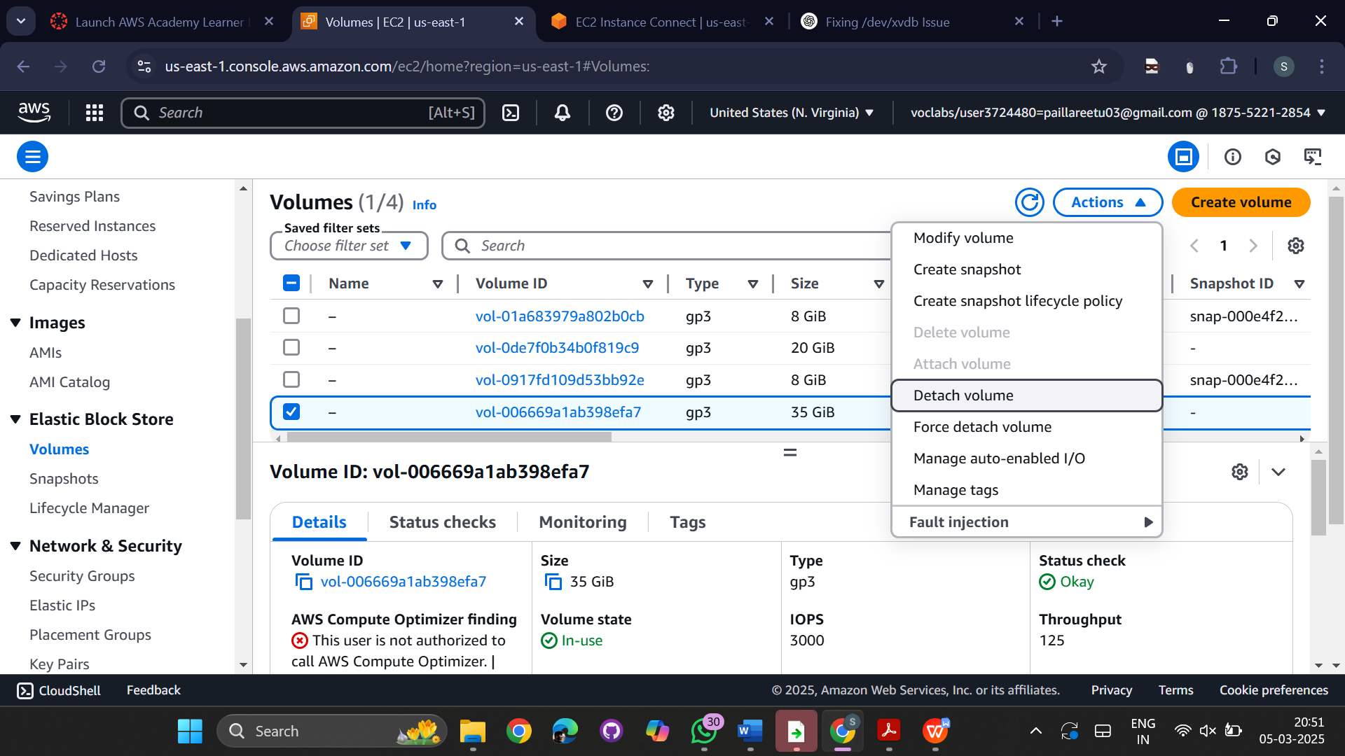

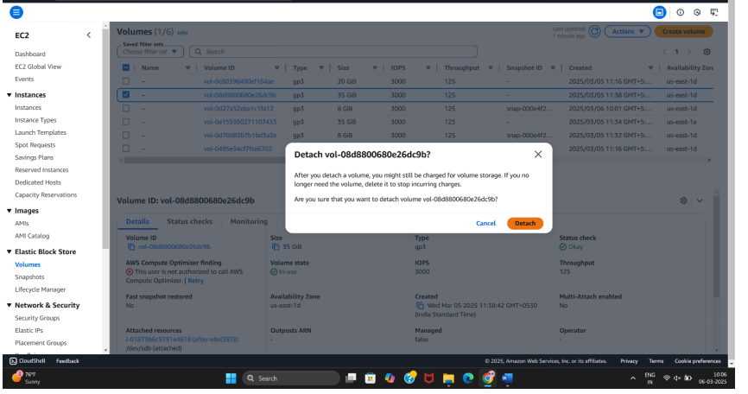

**Create another instance**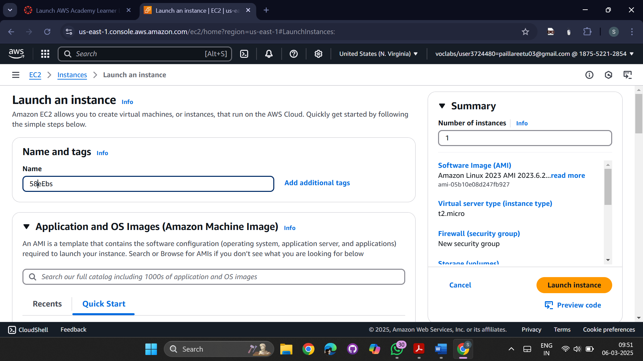  
**Attaching a Volume to Another Instance:**  
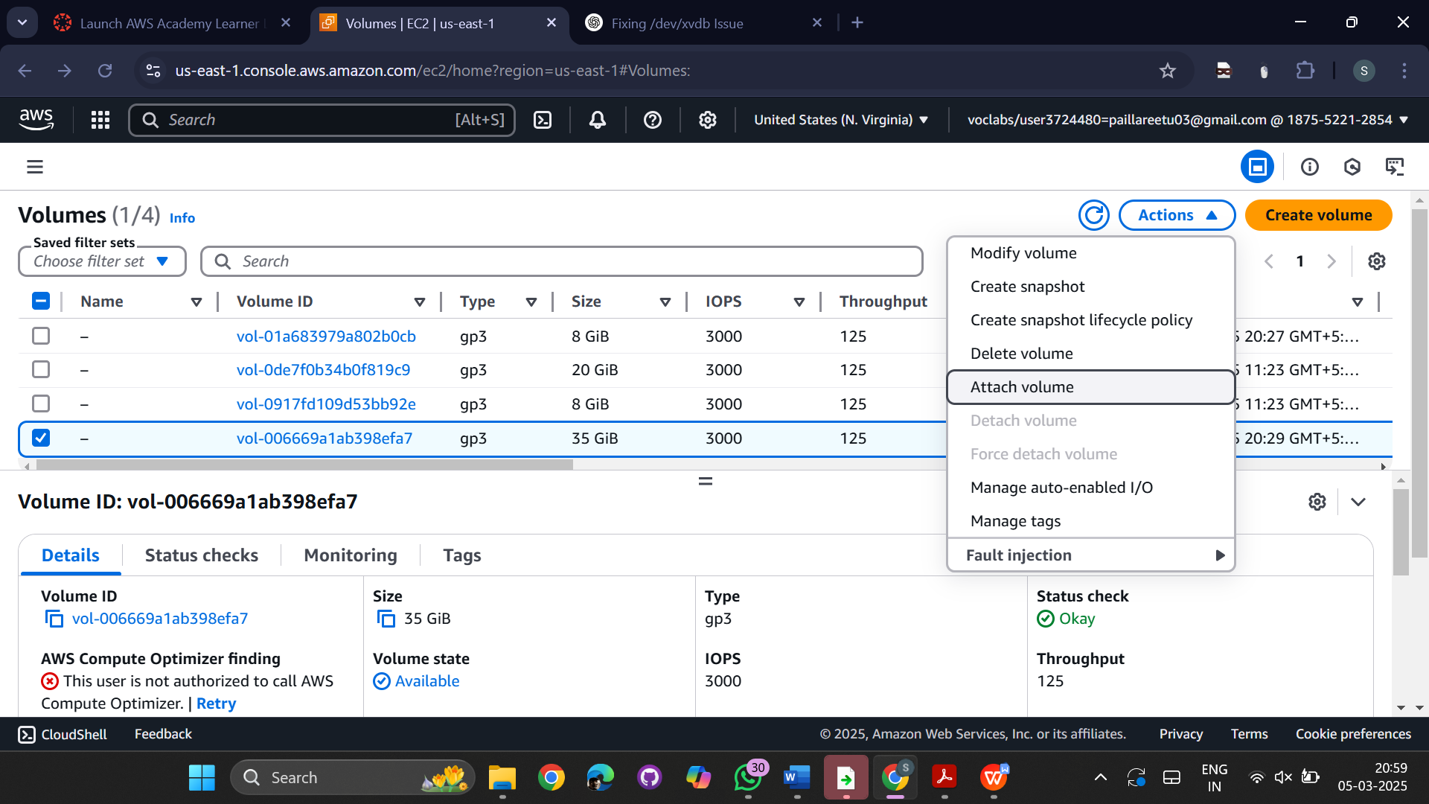

Choose the instances available in the region

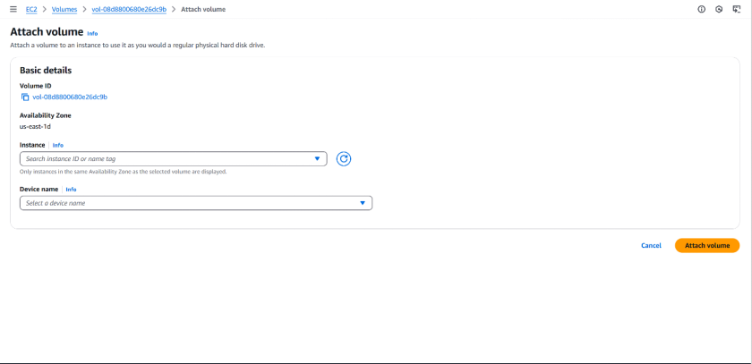  
  
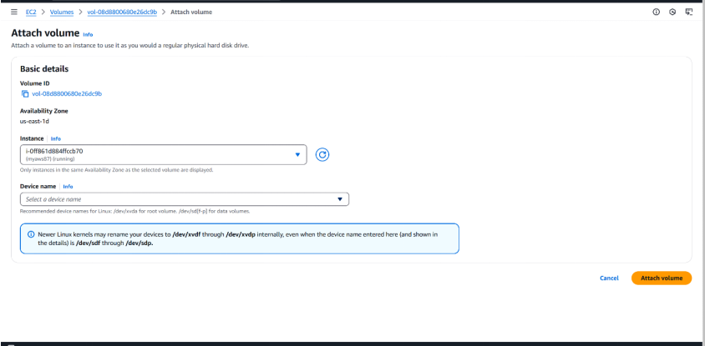

Select the device name  
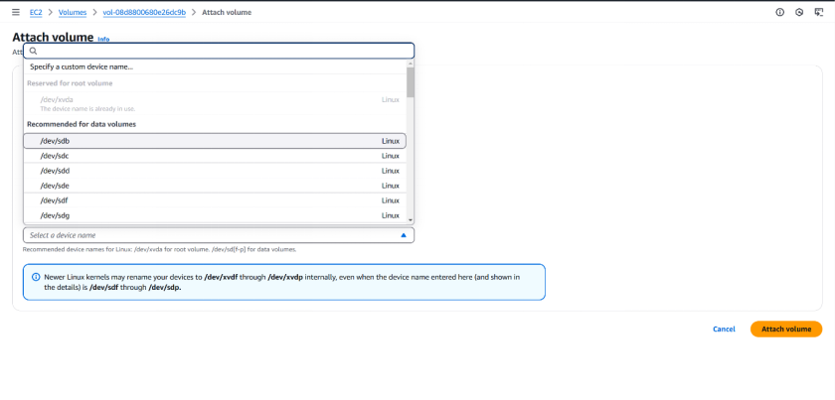  
  
  
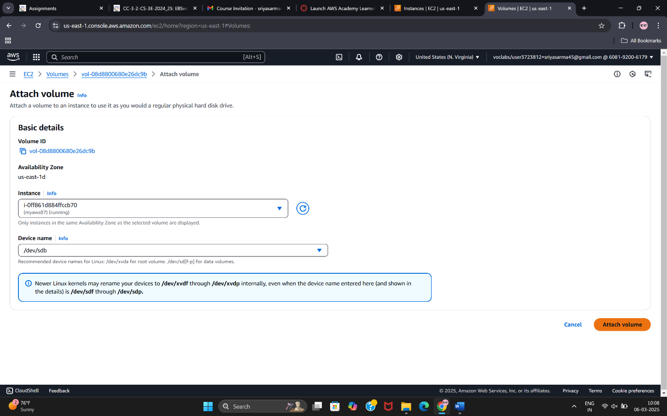

Now connect to the new instance   
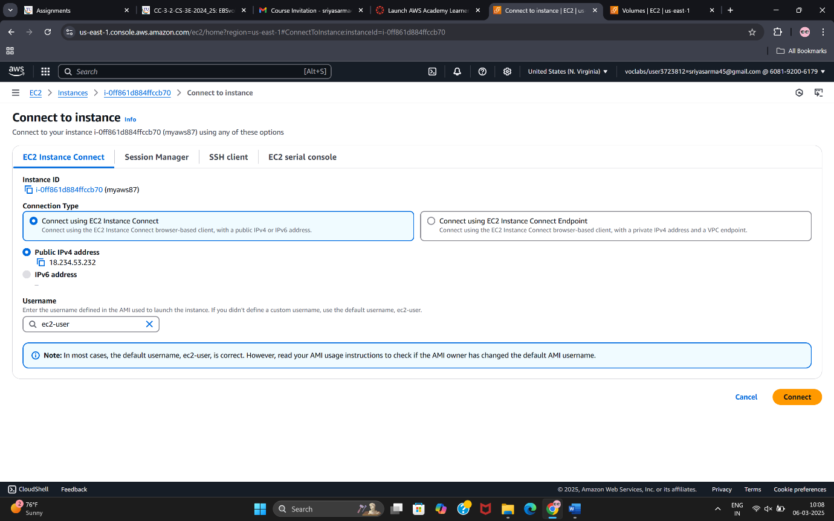

And run the commands:

->sudo su- for super super user  
-> lsblk -fs -listing out the availability  
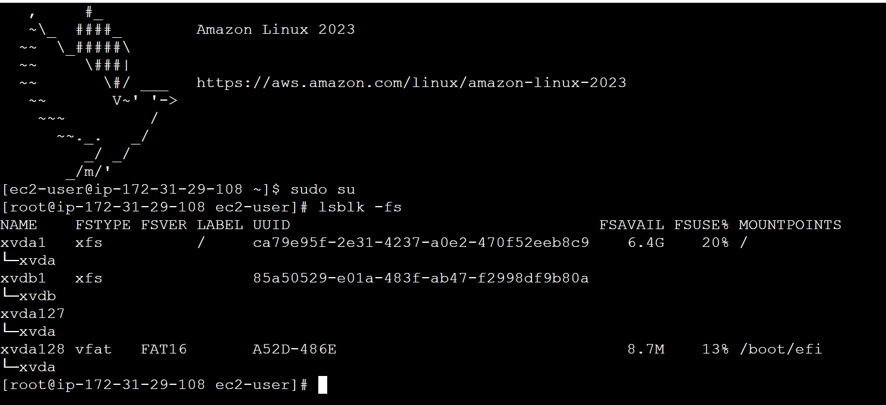

Mount the volume check whether reflected in this virtual machine